OFFICIAL INTERNATIONAL PUBLICATION OF THE ASSOCIATED LOCKSMITHS OF AMERICA, INC.

Volume 45, Issue 3

**savvy.**

Business skills and an eye for the most efficient software play important roles in your success.

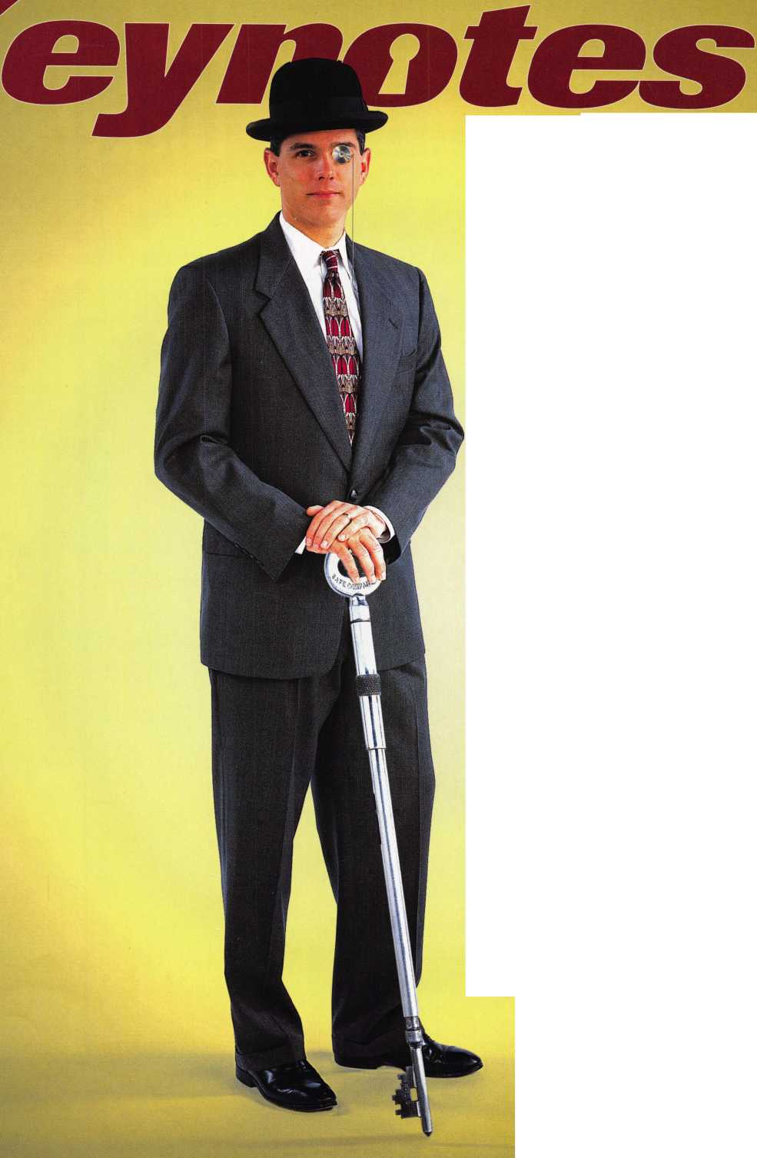

*J\**



Feel

Luckv?

You wouldn’t dream of leaving your success to chance. You know that making it in the safe and vault industry requires hard work, continual improvement of techniques, and constant research of the latest products and tools.

Your best bet to excel in all these areas is SAFETECH ’99 where you can save your luck for the casinos, and get down to business viewing the latest products, talking with the manufacturers, and training in the latest methods of safe and vault technology.

/



Make your plans now to attend  
SAFETECH ’99 May 3-8, 1999  
in Las Vegas, NV.



/

/1 /' * jp



**LAS VEGAS, INIV « MAY 3-B**

Contact:

Safe and Vault Technicians Association

3003 Live Oak Street Dallas, TX 75204 214.827.7233 214.827.1810 fax email: [convtion@anet-dfw.com](mailto:convtion@anet-dfw.com)



**J U LY 2 5 — 31**



Into classes, into networking,  
into the latest products.

This year, don't miss the best  
locksmithing trade show and education  
event of 1999-the ALOA Convention  
and Security Expo. Discover the city  
that boasts Fountain Square, riverboats,  
water parks and a breathtaking  
river view from Mt. Adams.

See you at the pool (the talent pool).

For more info, call 800.532.2563  
or check out [www.aloa.org](http://www.aloa.org)



**March**

99

Contents

Features

4

Presidents Journey

By Dallas Brooks

18

6

Upcoming Events



It’s the American Dream...But It Sure Isn’t Easy!

ALOA instructor Jim Rushing explores the ups and downs of starting your own business or as he calls it, “The American Dream.”

By Mike Emery

20

Computer Shortcuts

You work, work and work, but never seem to get caught up.

The best shortcuts are probably right in front of you.

Learn how to work smarter and not harder.

By Claire Cohen, CML

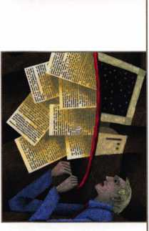

22

Business Growth Requires Modern Software Solutions

Our author examines how one lock shop benefited from a groundbreaking new computer program.

By Paul Chandler, CRL

24

Car Keys and Computers

Blackhawk introduces computerized code programs that are user-friendly and affordable.

By Sal Dulcamara, CML

28

Magazine Cross Reference from Data Logic

You think you saw an article about a certain type of hardware but aren’t quite sure what magazine it was in. Thanks to Data Logic, you can find the article you need in no time.

By Sal Dulcamara, CML

8

Security Marketplace

10

Applicants for Membership

Scheduled for clearance April 1.

12

Core

Meilink acquires NKL and Gary Safe, plus announcements concerning ALOA ‘99.

43

Authors in this Issue

44

Backpage



30

The Cover:

Today’s locksmith wears many hats...and suits! This month we review products and methods to make the skilled locksmith savvy in the business world.

Cover photo Steve Hinds Photography, Dallas, TX

Art direction Valerie Rowe

Graphic design Lori Brennan

Legislative Comment

Get the facts on what bills will be passed from ALOA’s own legal eagle.

By Tim McMullen

32

The Locksmith Business Card

One of the first things a customer sees is your business card.

How should it look? What should it say? Learn more from the man they call the “Island Locksmith.”

By Michael A. Ferrill

35

So, You Think You Want To Be A Small Town Locksmith?

Mayberry was a nice place to live, but would you want to be a locksmith there? Our author explains that big city locksmithing and small town locksmithing are like night and day.

By C. D. Lipscomb, CML, CPS

36

Associate Members

40

Classifieds

41

Ad Index

March 1999

2]_ Keynotes



[Staff)

Executive

3oard

Editor

Technical Editor

Communications Assistant Editorial Advisor

Advertising Sales Contributing Authors

ALOA Professional Staff Executive Director

Operations Manager

Receptionist Mail Room Assistant Comptroller Finance Coordinator Meetings Manager

Meetings Coordinator Government Affairs Manager

PRP/Education Manager

Education Assistant Membership Manager

Membership Coordinator

Chapters & Regional Associations Liaison

Mike Emery [keynotes@anet-dfw.com](mailto:keynotes@anet-dfw.com) David Lowell, CML, CMS [david@aloa.ioffice.com](mailto:david@aloa.ioffice.com) Patanya Johnson John D. Cannon, CML [jdcannon@worldnet.att.net](mailto:jdcannon@worldnet.att.net) Marvin Diamond Lionheart Publishing (770) 431-0867, ext. 208 Jerome V. Andrews, CML Paul Chandler, CRL Claire Cohen, CML Brian Costley, CML, CMS Bob De Weese, CPL Ray D’Adamo, CML Sal Dulcamara, CML James Glazier, CML Daniel Graffeo, CRL, CMS Wayne Gurnee, CRL A.J. Hoffman, CML Ken Holmlund, CRL Ray Lusk, CML Mark Ohno Randy Simpson, CML Robert Stafford, CPL Dave Thielen, CML

Charles W. Gibson, Jr., CAE charlie@aloa. ioffice.com Mary May

[mary@aloa.ioffice.com](mailto:mary@aloa.ioffice.com) Faye Brown Jeff Jordan Kathy J. Romo Janelle Vergara Jessica Smith [jessica@aloa.ioffice.com](mailto:jessica@aloa.ioffice.com) Janelle Vergara Tim McMullen [tim@aloa.ioffice.com](mailto:tim@aloa.ioffice.com) David Lowell, CML, CMS [david@aloa.ioffice.com](mailto:david@aloa.ioffice.com) Ashley Spencer Brandon Durrett [brandon@aloa.ioffice.com](mailto:brandon@aloa.ioffice.com) Jackie Arnett [jackie@aloa.ioflfice.com](mailto:jackie@aloa.ioflfice.com)

Tim McMullen [tim@aloa.ioffice.com](mailto:tim@aloa.ioffice.com)

Additional contact information for the ALOA Board and most Keynotes authors are available through “Locksmith Search" on the ALOA website- [www.aloa.org](http://www.aloa.org) or by contacting the ALOA office at 3003 Live Oak Street; Dallas, TX 75204; [800]532-2562; FAX [214] 827-1810; e-mail [aloa@aloa.org](mailto:aloa@aloa.org).



Mission Statement: The Associated Locksmiths of America, Inc. is dedicated to enhancing the professionalism, education and ethics among locksmiths and those in related sectors of the physical security industry. With approximately 10,000 members in the United States, Canada and the freeworld, ALOA is poised to help members obtain the knowledge, the strength, and the confidence to perform their role in the physical security field with pride and dignity. But it is only through active involvement and participation that ALOA can fully achieve its potential-and can help members to achieve theirs.

Policies: **Keynote**s? is the official publication of the Associated Locksmiths of America, Inc. (ALOA). **Keynote**s® acts as a moderator without approving, disapproving, or guaranteeing the validity or accuracy of any data, claim, or opinion appearing under a byline or obtained or quoted from an acknowledged source. The opinions expressed by the authors do not necessarily reflect the official views of ALOA. Also, appearance of advertisements and new products or service information does not constitute an endorsement of products or services featured by the Association. The Association does not accept responsibility for the inaccuracy of any data, claim, or opinion appearing in this publication, due to typographical errors on the part of the authors, Association staff or its agents. Editor’s Note: This publication is designed to provide accurate and authoritative information in regard to the subject matter covered. It is provided and disseminated with the understanding that the publisher is not engaged in rendering legal or other professional services. If legal advice and other expert assistance is required, the services of a competent professional should be sought.

Authors’ Payment: Payment for eligible submissions to **Keynotes** will be based on the following criteria: topic time spent and past contributions. Authors who regularly submit to **Keynotes** are generally paid a higher rate. The latter is especially true of authors who write to fit specific editorial needs and submit said copy by **Keynotes** deadlines. As a general guideline: Average payment for a 750 word, business or ‘light’ technical article would be $200. Payment for a 1500 word article involving significantly higher time and research efforts would be $400.

Payment will not be offered for articles submitted by ALOA employees or members of the ALOA Board of Directors (unless material is of a technical nature), nor for articles submitted by a company that promote that company’s products or services. ALOA reserves the right not to pay for articles submitted by an individual® that promote a particular company’s products or services.

Disclaimer: The Associated Locksmiths of America, Inc., (ALOA), reserves the right to refuse any article for any reason. Additionally, ALOA reserves the right to edit amend or modify any article submitted for publication in order to preserve technical accuracy, clarity, fairness or grammatical correctness. ALOA will make the best efforts to notify the author of any changes. The extent of ALOA’s liability for any article or information contained therein will be a notice of correction or retraction in the next possible issue.

**Keynoted** (ISSN 0277 0792) is published monthly except for the combined June/July issue by The Associated Locksmiths of America, Inc., 3003 Live Oak St., Dallas, TX 75204-6186. Telephone: (214) 827-1701; FAX (214) 827-1810; e-mail [aloa@aloa.org](mailto:aloa@aloa.org). Subscription rates for members-$ 15.00 per year. Second class postage paid at Dallas, Texas. POSTMASTER: Send address changes to: **Keynotes,** 3003 Live Oak St., Dallas, TX 75204-6186. © Copyright 1999, All rights reserved. No part of the contents may be reproduced or reprinted in any form without prior written permission of the publisher.



President

Dallas C. Brooks (334) 826-8990

Secretary

John D. Cannon, CML (703) 960-6413

Directors, Northeast

James H. Glazier, CML (301) 831-5454 John C. Magee, III

1. 845-3434 William L. Young, CML
2. ) 647-5042

Directors, Southeast

Jeffrey S. Nunberg, CML, CMS (305) 324-8800 Donald R. Rule, CML (601) 324-2658

Directors, North Central

Mark E. Blum, CML, CPS (517) 482-5809 John J. Greenan (773) 486-2030

Director, South Central

Randy L. Simpson, CML (713) 780-7026

Directors, Southwest

Gordon Racine, CML (719) 384-4707 John I. Shandy, CML (303) 774-9791

Director, Northwest

Scott Henke, CRL, CPS (907) 248-3785

Director, Associate Members

Judd Penske (800) 634-5465

Non-voting Directors

Jerome V. Andrews, CML (216) 642-3900 Steve G. Engel, CML, CPP (920) 731-5400

Trustees

David M. Lowell,CML, CMS (800) 532-2562 Breck H. Camp, CML (770) 455-6244 Henry H. Printz, CML (973) 538-2737 Leonard J. Passarello, CPL (416) 752-7210 Edwin Toepfer, RL (416) 225-5589

Chairmen off International Affairs

Laurence P. Mills/Australia (129) 958-0445 Hans Mejlshede, CML/Europe FAX (453) 139-1004

Past Presidents

1995-1997 David Lowell, CML, CMS 1993-1995 Breck Camp, CML 1991-1993 Henry Printz, CML 1989-1991 Evelyn Wersonick, CML, CPS 1987-1989 Leonard Passarello, CPL 1985-1987 Joe Jackman, CML 1983-1985 Stanley Haney, CPL 1981-1983 Louis LaGreco, CPL 1979-1981 John Kerr, RL 1977-1979 Clifford Cox, CML 1974-1977 Charles Hetherington 1972-1974 Gene Laughridge 1970-1972 William Dutcher, RL 1968-1970 Constant Maffrey, RL 1966-1968 Harold Edelstein, RL 1964-1966 William Meacham 1962-1964 Robert Rackliffe, CPL 1960-1962 Edwin Toepfer, RL 1956-1960 Ernest Johannesen

March 1999

Keynotes

with Dallas Brooks

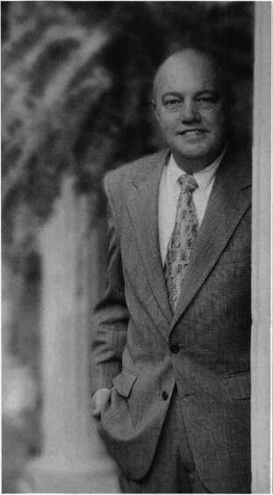

■

Local associations, do you participate?

In this issue, you’ll notice that Keynotes delves into the worlds of business and computers as they apply to our trade. Both are topics that are essential to all of us these days, and I’m sure that this issue will provide helpful information.

Likewise, I hope that we can use our association’s educational resources to learn more about such topics. It’s also my sincere wish that all of our members take advantage of the knowledge various local associations have to share and vice versa. By vice-versa, I mean that all those regional associations (be they affiliated with ALOA or not) look to our organization for assistance in similar areas.

It is ALOA’s intention to help advance the trade of locksmithing in several areas, and by working with smaller regional associations, we can do so more effectively.

One way we would like to help fellow locksmiths is through our education program. By working with ALOA, a local association or chapter receives discounted rates on ACE classes that can be held at meetings, conventions, tradeshows, swap meets and other sponsored events. I can’t tell you what a convenience this is for many people, particularly those in rural areas where classes are rarely conducted. Aside from helping other locksmiths become certified and educated, this also saves them time and money.

On the legislative front, our very own government affairs manager,

Tim McMullen is consistently updating local associations on the status of state legislation.

Another benefit that regional associations can enjoy from a relationship with ALOA is the national (and international for that matter) perspective we’re able to provide. Through our extensive network of members, resources and opportunities, we have access to knowledge otherwise not available to many local organizations.

As I write this, I’m planning a round table meeting at ALOA ‘99 in Cincinnati to discuss how we can be of service to local associations and develop stronger ties with them. I’ll certainly keep you abreast of how that turns out.

Strength in numbers has always been a sound concept and one that will benefit all of us as professionals, businessmen and locksmiths. I hope all of you take time to attend your weekly association and chapter meetings. Associations can be a very valuable tool for any technical trade, and the value of any tool can only be discovered if you use it.

See you in Cincinnati!

Dallas C. Brooks President



Keynotes

March 1999

Kwok-kei Leung

Henry Raymond

Toshihiro Asano

Stewart Levine, CML

Mary Ohmit, CPL

Charles Robertson, CML

Yuriko Yanai

Jack Hobin, CPL

Allen Konrath

Salvatore Dulcamara, CML_

Myeong-Rae Cho

William Neff, CML

David Lowell, CML

Thomas Freehling, CML

Dana Barnum, CML

Jeanne Lodge, CML

John Heckman, CML

Barry Leas, CRL

J. Thomas Hood, CML

Roy Renderer, CML

Danny Rudd, CPL

John Elliott, CML

Larry Warnick, CML

Lawrence F. Smith, Jr., CML

James Watt, CML

Robert Carroll, CPL

Diana Barnum, CRL

Barbara Watt

David M A Federico

Robert DeWeese, CPL

Jim Williams

Anthony Ramunno, CML

Jerome Cohen, CML

Eugene Altobella

Charles Cole, CML

Elvis Hammerschmidt, CPL

Marian Swann, CRL

John Dorsey, CPL

D. Michael Lee, CPL

James Fowler, CML

David Harris, CML

John Kerr, RL

Ronald Heidzig

Joseph Ferrero, CML

James Cawby, CML

William Grant, CRL

Philip Rovenolt, CPL

Michael Robinson, CRL

170

_93

_87

_67

_64

_63

_61

_51

_49

_39

_38

_35

_32

_32

_31

_30

_29

_28

_26

_25

_24

_24

_24

_24

_23

_23

_22

_22

_22

_22

_22

_21

_21

_21

_19

_19

_18

_18

_18

_18

_18

_17

_17

_16

_16

_16

_16

_16

Herbert Dusenberry, CML

Raymond Lusk, CML

Robin Horsley

John Engel, CRL

Donald Shiles

Thomas Demont, CML

Ernest Wright .

William Wickward, CML _

Lester Brodsky

Joseph Whitaker, CPL

Dale Knowles, CPL

Brian Reetz —

Walter Lascar, RL

Thomas Vandersteen, CML

Gary Teams, CPL

William McElheney, CML.

Rex Parmelee, RL

James Gruber, CRL

Keizo Takahashi

Robert Duman, CML

Russell Fuller, CRL

Edwin W Scott

Peter Gauthier, CPL

Frank Hartung, CML —

Jon Griswold, CML

PaulSouber

Richard Sievers

Daniel Landry .

Steven Spiwak, CRL

Robert Rodocker, CRL

Keiryu Tsukishiro

Rolando Bouza

Lonnie McKinney, CML . James Brickler, CRL —

Joe Lee, CRL

Eric Veal

Best.

How can I join the President's Club?

You can earn membership in this prestigious club by recruiting just 10 new members for ALOA.

*Any ALOA member may participate.

What do I get?

When you recruit 10 members, you receive a handsome blue blazer with a President's Club crest. For each additional five members you recruit, you receive a lapel pin with gold-filled numbers, indicating your recruiting successes.

You also get the satisfaction of knowing that you are helping your association, helping your industry grow, and you are helping fellow locksmiths achieve success.

How do I get started?

Contact the ALOA office for a supply of applications (800) 532-ALOA or FAX (214) 827-1810. One President's Club credit is awarded for each new applicant. Credit is awarded only after the membership application is approved. However, the credit will apply for the period in which the application is received. Failure to identify yourself as the sponsor on the application form at the time it is submitted to ALOA for processing will forfeit any credit.

*AL0A Board of Directors not eligible for membership in the President's Club.



Upnnming

Events



Dept)

Indicates ALOA ACE Class

Indicates PRP Sitting

1999

MARCH

9-12

ISC Expo/Las Vegas ’99 Las Vegas, Nev.

Contact: (203) 840-5602 <http://isc.reedexpo.com>

1. 14

IDN Hardware Sales, Inc. Security Conference Cleveland, Ohio Contact: Fred Strasberger, John Kress or Bonnie Weston (800) 521-0955

1. 14

Spring Retreat & Classes by Jerry Levine Inn of the Ozarks,

Eureka Springs, AR Contact: Betty Gray (501) 524-3660 day (918) 427-1066 evenings or Bill or Janis Reves (501) 631-0017 day (501) 6 31-6406 evenings

18-21

**\fcr\** ACE Classes Sponsor:

MLANJ Annual Convention Somerset, NJ (973) 267-8884 (973) 538-2248 fox [www.mlanj.org](http://www.mlanj.org)

20

/ ALOA PRP Sitting

MLANJ

Somerset, NJ

Contact: Bill Tlmmann, CML (973) 267-8884 (973) 538-2248 fax

20-21

MBA Training, Manipulation Nicholasville, Ky.

(888) 622-5495

21

Southern Lock Buyers

Trade Show

St. Petersburg, Fla.

Contact: (800) 282-2837

1. 27

ACE Classes Hammond, LA Lou-Miss Locksmiths Assoc. Contact: Thomas Hunt, CML **(205)833-3333 (205) 836-3333 fax**

28

**^** ALOA PRP Sitting Rosemont, 111.

Clark Security Products Contact: Terri Burges (619)974-5273 (619) 974-5284 fax

28

ALOA PRP Sitting Hammond, LA Lou-Miss Locksmiths Assoc. Contact: Tommy Hunt, CML (205)833-3333

APRIL

9-11

ALOA Spring Board Meeting

Hilton Atlanta Airport & Towers

Atlanta, Georgia

Contact: Mary May

(214) 827-1701

(214) 827-1810 fax

email: [mary@aloa.ioffice.com](mailto:mary@aloa.ioffice.com)

11

/ ALOA PRP Sitting Oakland, Calif.

Clark Security Products Contact: Terri Burges (619)974-5273 (619) 974-5284 fax

11

**^** ALOA PRP Sitting Oakland, Calif.

Clark Security Products Contact: Terri Burges (619)974-5273 (619) 974-5284 fax

12-16

MBA Training DoD Combination Locks Nicholasville, Ky. (888)622-5495

17-18

MBA Training Professional Safe Drilling Nicholasville, Ky.

(888) 622-5495

20-21

ASTM Meeting on Security Systems and Equipment Seattle, Wash.

Contact: Cynthia Blackwell (610) 832-9737

MAY

3-8

SAFETECH ’99 Las Vegas, Nev.

(214)827-7233

15

MBA Training Expert Lock Picking Nicholasville, Ky.

(888) 622-5495

16

MBA Training Expert Lock Picking Nicholasville, Ky.

(888) 622-5495

JUNE

19

MBA Training Safe Deposit Locks Nicholasville, Ky. (888)622-5495

20

MBA Training Time Locks Nicholasville, Ky. (888)622-5495

JULY

25-31

ALOA ’99 Security Expo Cincinnati, Ohio (800) 532-2562

AUGUST

i

ACE Classes

ALOA ’99 Security Expo Cincinnati, Ohio (800) 532-2562

6-7

ACE Classes Albuquerque, MN New Mexico Locksmiths Assoc. Contact: Steve Highland (505) 268-8663 (505) 268-8802 fox

8

**fjk** ALOA PRP Sitting Albuquerque, NM New Mexico Locksmiths Assoc. Contact: Steve Highland (505) 268-8663 (505) 268-8802

18-21

ACE Classes SERLAC Orlando, FL

Contact: Austin Curry, CRL

(813)837-8488

(813) 839-1825 fax

22

**^** ALOA PRP Sitting Baltimore, Md.

Clark Security Products Contact: Terri Burges (619)974-5273 (619) 974-5284 fax

22

ALOA PRP Sitting Orlando, FL SERLAC

Contact: Austin Curry, CRL (813) 837-8488 (813) 839-1825 fax

1. 30

MLA’s London Convention Contact: Dave Stokes 139 Wood Street Walthamstow,

London, E17 3LX 01144 181 520 7450

SEPTEMBER

15-19

GPLA Annual Convention Philadelphia, PA Contact:

Jack Magee (registration)

(609)845-3434

Don Amole (booth space)

(215) 288-5588

[www.gpla.org](http://www.gpla.org)

18-19

Distributors Show Inn of the Ozarks,

Eureka Springs, AR Ozark Professional Locksmith Association Contact: Betty Gray (501) 524-3660 day (918) 427-1066 evenings or Bill or Janis Reves (501) 631-0017 day (501) 631-6406 evenings

OCTOBER

10

/ ALOA PRP Sitting Burbank. Calif.

Clark Security Products Contact: Terri Burges (619)974-5273 (619) 974-5284 fex

17

/ALOA PRP Sitting Penn/Ohio Locksmith Assoc. Coraopolis, Pa.

**Contact: Martha R. Eggler** (216)676-8464 (216) 267-2511 fax

2000

APRIL

6-9

MLANJ 2000 Annual Convention Somerset, NJ (973) 267-8884 (973) 538-2248 fax [www.mlanj.org](http://www.mlanj.org)

MAY

1—6

SAFETECH 2000 Birmingham, Ala. (214)827-7233

JULY

23-30

ALOA 2000 Las Vegas, Nev. **(214)827-1701**

2001

MARCH

1. April 1

MLANJ 2001 Annual Convention Somerset, NJ (973) 267-8884 (973) 538-2248 fax [www.mlanj.org](http://www.mlanj.org)

JULY

15-22

ALOA 2001 Security Expo Baltimore, Md.

(800) 532-2562

2002

JULY

21-28

ALOA 2002 Security Expo Rosemont, 111.

(800) 532-2562

***Keynotes***

March 1999

The ALOA Scholarship Foundation is gearing up to award scholarships for 1999. Last year, 28 scholarships were awarded. There were two scholarships awarded to attend classes at SAFETECH ’98 in Valley Forge, 25 awarded for classes at ALOA ’98 in Nashville, and one awarded to attend classes at Yankee in Rhode Island. Scholarships are awarded to those individuals who demonstrate their financial need and their desire for more education in the locksmithing field. If you or someone you know fits the above crite­ria, please fill out the application on this page and send or fax to the ALOA Office at 3003 Live Oak St., Dallas, Texas 75204 by the due date on April 1, 1999. The fax number is (214) 827-1810. Don’t forget to include your letter stating your reason for applying, your three letters of reference and your financial information. No late or incomplete applications will be considered.

ALOA SCHOLARSHIP FOUNDATION, INC.

ALOA/SAVTA SCHOLARSHIP APPLICATION  
3003 Live Oak Street; Dallas TX 75204; (214) 827-1701

Please print or type

NAME PRP LEVEL ALOA/SAVTA #

HOME ADDRESS

CITY

STATE ZIP

HOME PHONE PRESENT EMPLOYER WORK ADDRESS

DOB

_/ EDUCATIONAL LEVEL {YEARS) DEGREE, IF ANY.

WORK PHONE- FAX -.

CITY STATE ZIP

POSITION □ FULL TIME □ PART TIME TAKE HOME PAY $

LENGTH OF TIME IN LOCKSMITHING OWNER/SUPERVISOR’S FULL NAME MEMBERSHIP IN TRADE ASSOCIATIONS (LIST BY NAME)

MARITAL STATUS SPOUSE’S OCCUPATION SPOUSE’S TAKE HOME PAY $

COMBINED HOUSEHOLD ADJUSTED GROSS INCOME $ NUMBER OF DEPENDENTS

CLASSES DESIRED DATE OF CLASSES //

ORGANIZATION SPONSORING CLASSES: □ ALOA □ SAVTA □ OTHER (PLEASE NAME)

LOCATION

ALOA Scholarships are granted to selected individuals desirous of entering the locksmithing field or to selected individuals already in the locksmithing field who wish to improve their professional skills through education.

Applications for classes being taken locally must be received a minimum of 60 days prior to the date of the class, and will be reviewed as they are submitted. Scholarships for classes at the ALOA or SAVTA convention will be awarded each year at the ALOA Scholarship Foundation meeting preceding the convention and must be received by April 1 each year.

Please attach to this form a letter stating your reason for applying for a scholarship, what you plan to do with the knowledge you obtain and any other information you feel may be helpful to the scholarship board in making its decision. In addition, attach three let­ters of reference from individuals who have personal knowledge of your background and character. The letters should contain their names, addresses and phone numbers. It would be helpful if at least one of these references is an ALOA or SAVTA member. Also, please provide a copy of your most recent tax return.

All scholarship recipients will be required to provide a 3x5 inch photograph of themselves.

APPLICATION CHECK LIST

Only complete applications will be considered for scholarships. An application is considered incomplete unless ALL of the above requested information is received before the deadline: 60 days prior to the date of a class or April 1 for ALOA/SAVTA convention classes. Please send this application after checking off each of the below.

* I have filled in each blank on this form.
* I have written and enclosed a letter explaining my reason for applying.
* I have enclosed three letters of reference.
* I have enclosed a copy of my most recent tax return.
* I am submitting this in time to be received 60 days prior to the date of a class or by April 1 for ALOA/SAVTA convention classes.

CERTIFICATION OF APPLICANT:

I certify that the information contained herein, and all supplemental forms are complete and correct to the best of my knowledge.

I further certify that if I am selected as a scholarship recipient I will use the knowledge gained for the improvement, development and advancement of the locksmithing profession.

Signature Date//

01/99

March 1999 ***Keynotes \***



Creative Commands Corporation

Creative Commands Corp. has introduced a security gate transmitter/receiver that is activated from the cigarette lighter of your car. Handy-Touch, is designed for use any­place accessible through an electric gate. It installs in minutes on all security gate open­ers and connects to existing opener hard­ware. It has a range up to 150 feet and works parallel with other transmitters. Handy-Touch operates at a frequency proven to be secure against electronic “code-grab­bers,” 910 MHz. It uses code-rolling tech­nology, a system that has billions of operat­ing codes that change every time the securi­ty gate is opened or closed. The Handy- Touch transmitter is available in sizes to fit most American, Japanese and European cars and trucks and requires no modification to the electrical system.

Creative Commands Corp.

3121 Fujita St., Dept. P Torrence, CA 90503 (310)530-1965 (310) 530-9219fax

DoorKing Inc.

DoorKing Inc., a manufacturer of access control products, announced that it has added security levels and elevator control to its “PC Programmable” series of telephone entry and access control systems. Models 1815 and 1817 now include 29 programma­ble security levels, with each level having four programmable time zones. System administrators can restrict access for users as needed. The elevator control capability can be used in two different ways, either visitor control or security levels. In a high rise apart­ment building, managers can set the system so that a guest can only access the floor that the resident, who granted them access, resides on. Security control only allows the user to use the floors that have been assigned to their security level. Up to four elevators can be controlled and the added feature of Hold Open Time Zones is also available for the controlled entry locations.

DoorKing Inc.

Sales Department (800)826-7493

81 ***Keynotes***

Cold Steel

Two new knives are available from Cold Steel. El Hombre, a folding lockback knife and Land & Sea Rescue knife. El Hombre weighs 33 oz and has a 4-inch blade that is razor-sharp. El Hombre also features thumb studs on each side of the blade, allowing the knife to be opened with either hand. It has a rich, black finished stainless steel pocket clip that provides safety in transporting. Both a serrated and non-serrated blade edge is avail­able. Cold Steels Land & Rescue knife has a big, wide, flat thin, ground blade, with a razor- sharp serrated edge. It also features a round “sheep s foot” point that is less likely to cause injury. The handle is a 5-inch non-slip Zytel with lanyard hole, one-handed opening and a weight of just 3.4 oz. In emergencies it can be opened in the blink of an eye. Both knives are made from AUS 8A stainless steel, a high-carbon, low-chromium steel that has proven to be the compromise between tough­ness, strength, edge-holding ability and corro­sion resistant for over 15 years.

Cold Steel

2128-D Knoll Drive Ventura, CA 93003 (800)255-4716

Wells Lamont

Wells Lamont Industrial (WLI), one of the nation s manufacturers of work gloves, has expanded its coated and unsupported glove line to provide a selection for individuals working in industrial environments. New coated styles include heavyweight nylon knit with rubber coat­ed palm fingers, Jersey with PVC “broken bub­ble” finish on palms and fingers and double dipped latex with removable and washable acrylic terry liners. These gloves provide coating and protection. In addition, new styles of unsupported Nitrile are capable of resisting oil-based solvents and petroleum, unlike natural latex. The unsup­ported styles are used for maintenance, food pro­cessing, machine operation and painting. Other unsupported styles are also available in neoprene. Neoprine offers protection against alkalines and acids.

Wells Lamont 6640 W. Touhy Ave Niles, IL 60714-4587 (847)647-8200; (847)647-6943 fax

Security Lock Distributors

Now available from Security Lock Distribu­tors is the full line of locking devices and acces­sories of Mas-Hamilton. Security Lock will dis­tribute the well known Auditcom, Vindicator and Model 50 locks as well as the newest access control device, PowerLever electronic keyless door locks. The new locks contain such features as keyless entry, no wiring, user-changeable PINs and a variety of other features.

Security Lock Distributors (800) 847-5625; (800) 878-6400fax [SECLOCK@IX.NETCOM.COM](mailto:SECLOCK@IX.NETCOM.COM) wunv.seclock.com

SANYO

Sanyo Security Video released new line of time-lapse recorders. The SRT-6000, SRT-7072 and SRT-7168 offer front panel jog/shuttle con­trol, advanced recording, tape protection system and RS-485 control using Sanyo-designed Secu­rity Serial Protocol (SSP), a communications method for interfacing between various compo­nents of a security video system. This will sim­plify system design and produce a more efficient system. The three recorders have a jog/shuttle control on the front panel, for easier access and operation of the tape-search function. The shuttle control allows easy fast forward and reverse tape viewing. The shuttle control also features a lock- down mode for hands-free control. The jog con­trol allows easy forward and reverse individual picture viewing. The recorders offer Sanyo an exclusive advanced recording and tape protection system and also an exclusive tape jam-protection system for cylinder tape-jam problems. The SRT- 7072 offers 72-hour real-time recording with 96 hours of total recording time. The SRT-7168 and SRT-6000 offer 24-hour continuous real-time recording. The SRT-7168 offers the flexibility of selecting up to eight recording speeds for both the T-160 and T-120 tapes, and has a record­ing/playback capability of up to 168-hours. The SRT-6000 offers three recording speeds and has up to 40 hours of recording capability. These recorders are the first generation of security prod­ucts capable of communicating directly with controllers built by another manufacturer who has SSP built into its controllers.

Sanyo Security Video, Product Division (818) 998-7322

March 1999

Jensen

Jensen has introduced a full line of high quality digital multi-meters and cur­rent clamps.

The line provides a very good value, cost­ing much less than comparable meters. From the full-featured JTM-105, a true-RMS meter, to the JTM-63, Jensen Tools offers a three year “no hassle” warranty.

Jensen Tools

7815 S. 46Tb Street

Phoenix, AZ 85044

(800)426-1194

(602)968-6231

(800) 366-9662fax

tvtow.jensentools.com

NAPCO Security Group

NAPCO Security Group announces their new control panels, the Gemini GEM- P3200 & GEM-9600, both support two- way communication with home or building automation systems. NAPCO s panels out­put virtually 100% of the detection informa­tion sought as input for automation system integrators. Unlike other systems, Gemini communicates movement and stimuli with­in its detection network of PIRs, contact switches, and keypads-whether armed or dis­armed. The system is always monitoring and triggering control functions, such as room temperature, zones, moods of lighting and pin-pointed occupancy routines, etc. Just as automation systems are being designed to be upgradeable to new technologies, NAPCO s Gemini security products are also capable of being upgraded for functions that can only now be imagined. They can be configured in the future to accommodate any level of automation package.

NAPCO (800) 645-9445

Secure Key

Secura Key announces the new SK-NET Access Control software, which was designed for use with the new ENTRACOMP 28SA- Plus Smart Access Control Unit. When the two are used together, they control up to 128 doors. The SK-NET communicates to the 28SA-Plus units via a high-speed net­work, which allows cable distances of up to 4000 feet. The 28SA-PLUS offers True

Security

Marketplace

Anti-passback, which tracks cardholders’ in and out status between multiple 28SA’s, even without a PC on-line. The ENTRA­COMP 28SA-Plus’ slotless design is highly weather and vandal resistant. It also features TOUCHCARD Technology, one of the most reliable and stable card technologies in the access control industry.

Secura Key

20447 Nordhoff Street Chatsworth, CA 91311 -6112 (818) 882-0020 (818) 882-7052fax

Corby Industries inc.

Corby’s System 2 has been packaged into Starter Kits with step-by-step installation instructions. Each kit contains two outdoor readers including: Data Chip, Magnetic Strip, Wiegand or Proximity with 50 cards or data chips and 200 feet of wire. For instal­lations requiring Keypads, a kit is also avail­able with two heavy-duty outdoor Keypads, two custom back-boxes and 200 feet of wire. With the addition of a door lock and power supply for the lock, the installation is com­plete. System 2 supports thousands of users, full duplex RS232, 16 time schedules (1024 time zones), anti-passback, temporary users, two zone inputs, two auxiliary relays, two voltage outputs, generic 26-bit Wiegand capability, forced entry, door ajar, request-to- exit and an emergency drop input. The sys­tem can easily be expanded into a large 16 door system, by linking multiple units together using a high speed RS485 BUSS. Users can be added or deleted in seconds using the built-in programming keypad and 48 character Liquid Crystal Display. A Video Display Terminal or PC can be added for on­site or remote programming. After data has been programmed, the built-in backup pro­gram can be used to save all system and user data to a floppy disk.

Corby Industries Inc.

1501 E. Pennsylvania St.

Allentown, PA 18103 (610) 433-1412

Crisis Prevention Institute

A new training video teaches staff mem­bers how to prevent crisis situations from arising while dealing with nonverbal indi­viduals. Communication can be difficult and communicating with someone who is non­verbal can be even more challenging. Nonverbal individuals are those who cannot speak or have limited verbal skills. When trying to communicate with nonverbal indi­viduals, misunderstanding and frustration are common and can lead to crisis incidents and explosive situations. The video released by the Crisis Prevention Institute, “Louder than Words: How to Intervene with Nonverbal Individuals, includes tips, advice and exercises for staff to use.

Crisis Prevention Institute 3315-K North 124th Street Brookfield, WI53005 (800) 558-8976

DREMEL

Dremel has introduced a Professional High Speed Rotary Tool for locksmiths who constantly have a tool in hand and demand power, versatility and dependability. The new professional-grade tool was designed specifically for heavy, long-term usage and is equipped to tackle a variety of jobs, includ­ing cutting through steel and other tough materials, installing locks, access hardware, engraving, cleaning, polishing locks and much more. Dremel added enhancements to meet the needs of the professional tool user. Some of these enhancements include an elec­tronic feedback controller, a digital LCD readout, a unique fan to keep the tool’s motor cool and a “soft-start” system. The Professional High Speed Rotary Tool com­plements the existing Dremel system and can use more than 150 of the existing bits.

Dremel

4915 21St Street Racine, WI 53406-9989 800-4 Dremel (437-3635)

(414) 554-1390 (414) 554-7654fax

***Keynotes*** li

March 1999

Applicants

For Membership

|  |  |
| --- | --- |
| USA | CONNECTICUT |
| ARIZONA | New Haven |
| Mesa  028733, Thomas J. Beall, AP SPONSOR: John Ilk | 028725, Francis A. Manzi, A SPONSOR: Dale Hobbs  FLORIDA |
| Tucson | Lake Mary |
| 028741, Mark M MacLeod, A | 028720, James S. Neelley, A |
| SPONSOR: William Lee | ILLINOIS |
| CALIFORNIA  Benicia | East Peoria  028735, Gary K. Lawrence, A SPONSOR: Scott Kelso |
| 028724, James V. Clarke, A  Corona  028731, John Boyrazian, A | INDIANA  Brazil  025482, Noel E. Allen, A |
| SPONSOR: George Rodriguez | SPONSOR: Herbert Dusenberry |
| So San Francisco  028728, Michael R. Tomasa, A  COLORADO | LOUISIANA  Shreveport  028726, James K. Stevens, A |
| Limon | MICHIGAN |
| 028730, Daniel P. Groenendale, AP | Union City |
| SPONSOR: Raymond Cobb | 028721, J. W. Beckmeyer, AP |
| Pueblo  028716, David S. Collinsworth, A SPONSOR: Joe Collinsworth | MINNESOTA  Glencoe  028729, Bradley D. Olson, A |
| 028717, James B. Collinsworth, A | SPONSOR: Kevin Olson |
| SPONSOR: Joe Collinsworth | St Paul |
| 028718, Michael T. Collinsworth, A | 028732, David N. Sohl, A |
| SPONSOR: Joe Collinsworth | SPONSOR: Randall Berg |



***The following applicants are scheduled for clearance as members of ALOA. The names are published for member review and comment prior to April I, 1999, to ensure applicants meet standards of ALOA’s Code of Ethics. Protests, if any, should be addressed to the Membership Department and must be signed. Active Membership applicants (A) have worked in the indus­try two or more years. Allied Membership (AL) applicants are not locksmiths, but work in a security-related field. Apprentice Membership CAP) applicants have worked in the industry less than two years.*** ^

|  |  |
| --- | --- |
| NEBRASKA | JAPAN |
| Norfolk | Gun Saitama-Ken |
| 028739, Mark W. Voigt, A | 028713, Yoshihiro Kaminishi, A |
| SPONSOR: Elvis Hammerschmidt | SPONSOR: Toshihiro Asano |
| NEVADA | Saitama-Ken |
| Las Vegas | 028711, Takayuki Koyama, A |
| 028742, James A. Caster, A | SPONSOR: Toshihiro Asano |
| SPONSOR: Rebecka Caster | KANAGAWA |
| OHIO | Fujisawa |
| Fremont | 028714, Koji Ito, A |
| 028734, Anthony J. March, AP | SPONSOR: Toshihiro Asano |
| SPONSOR: Joel Smith | Sagamihara |
| Lakewood | 028715, Sadayuki Nakamura, A |
| 028723, Timothy R. Schall, AP | SPONSOR: Toshihiro Asano |
| SPONSOR: William Nehrenz | TOKYO |
| Maumee | Nakano-Ku |
| 028738, Edward D. Houston, A  PENNSYLVANIA | 028710, Toshiaki Ushida, A SPONSOR: Toshihiro Asano |
| Downingtown | Shinagawa-Ku |
| 028719, Craig J. LaLoup, A | 028712, Hisanori Kurashige, A |
| SPONSOR: D. Franklin | SPONSOR: Toshihiro Asano |
| WISCONSIN | |
| Eau Claire | KOREA |
| 028727, Lori J. Hartman, A | Paju, Kyungki Prov |
| SPONSOR: John Dorsey  BRAZIL  Belem-Para-Brazel  028707, Coimbra M. Antonio, A | 028708, Yong H. Kim, A |

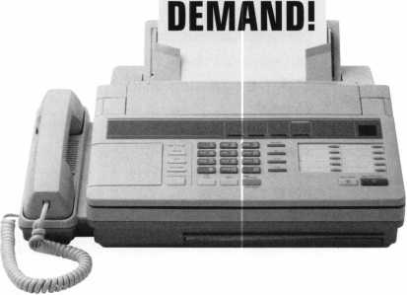

ALOA

HAS

FAXON

Need information in a hurry?

Just call 310.575.5074 and you will be faxed:

#1 A list of all documents available through this service #2 Becoming A Locksmith #3 Locksmith Career Summary #4 Locksmith School List #5 ACE Class Schedule #6 Certification Information #7 PRP Category List #8 ALOA Membership Application #9 ALOA List of Benefits

#10 Scholarship Application Form  
#11 ALOA Video Library Order Form  
#12 ALOA Membership Items Order Form  
#13 Safe & Vault Technicians Association  
Member Application/Subscription Form  
#14 ALOA Chapter Roster  
#15 Legislative Action Network  
#16 Legislative Action Network Newsletters  
#17 Various State Laws  
#18 Industry Position Paper

Your association continues to explore ways to provide you,  
our members, with new benefits and services.

10

Keynotes

March 1999

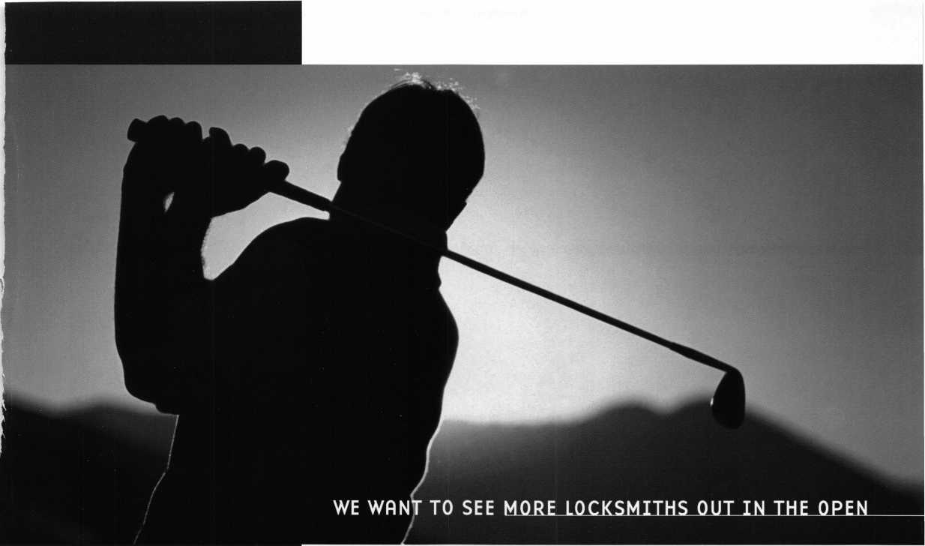

**Tickets to the PGA Championship**

...Out in the ALOA Open, that is. The ALOA Open Golf Tournament,

Medina Country Club in Chicago *courtesy Rosemont Convention Center*

sponsored by Yale Security Group Inc., and benefitting the

ALOA Scholarship Foundation, will be held Wednesday, July 28, 1999,

**Round-trip Airfare for Two**

*courtesy Allstate Insurance*

during the ALOA '99 Convention and Trade Show.

**Four Nights at the Rosemont Hyatt Regency**

*courtesy Hyatt*

Entry includes breakfast, green fees, a golf shirt and hat, and the evening dinner event. Everyone who enters is eligible to win one of many incredible prizes, including golf clubs, equipment

**Rental Car**

*provided by ALOA*

and clothing. And everyone who enters the tournament, or purchases a $100 banquet ticket is automatically entered in the grand prize drawing —

A TRIP FOR TWO TO THE PGA CHAMPIONSHIP!

A $150 tax-deductible donation to the ALOA Scholarship Foundation reserves your spot. But SPACE IS LIMITED! Send your name, address, phone number and ALOA Member Number (if applicable) right away to:

**SIGN ME UP!**

ALOA '99 Open Golf Tournament 3003 Live Oak Street Dallas, TX 75204

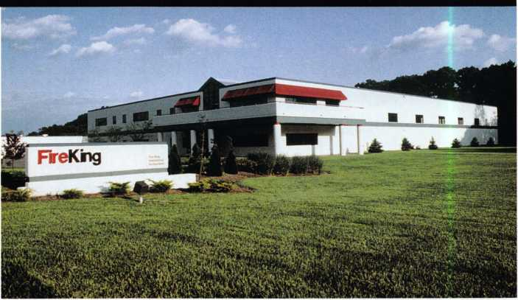

• Meilink acquires NKL

“Together we plan on building a formidable manufacturing and marketing power in the industry..."

Meilink Safe Company acquired NKL Industries and Gary Safe International this past January.

According to Van G. Carlisle, president and chief executive officer of Meilink’s parent company Fire King International Inc., NKL had suffered financial woes and turned to FireKing for the needed capital. The companies have been associated since Meilink made the first electronic safe, four years ago. The only major change was the consolidation of all accounting functions in New Albany, Ind., where Fire King is based.

The NKL subsidiary will be managed by former president Mike Smith and chief executive officer Ray Lorenzo who are retaining equity interest in the business.

“Not only are we getting a great company, but also some great human resource people that are real good in the design and marketing of the product,” said Carlisle. “Together we plan on building a formidable manufacturing and marketing power in the industry. We will be able to offer our dealers and distributors the most complete line products in the safe industry.”

Carlisle also stated that Meilink will forge a stronger, more profitable partnership with NKL’s locksmith network. Details on this subject will be announced at a later date.

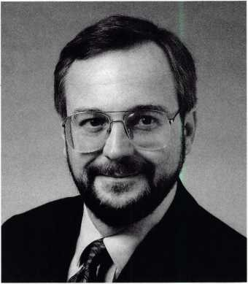

Wan G. Carlisle

Meilink, a division of Fire King Interna­tional Inc. is a producer of fire-resistant files, insulated safes and Winchester gun safes. NKL is a safe manufacturing company located in Chesapeake, Virginia and its subsidiary Gary Safe International is located in Waynesboro, Georgia. NKL produces electronic and cash handling safes, that are primarily used in fast food restaurants. The national accounts include McDonalds, Wendy’s, Hardee’s and the Tricon chain, KFC, Pizza Hut and Taco Bell.

— Patanya Johnson

^ ***Keynotes***

March 1999

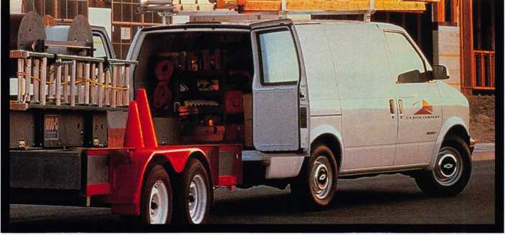

• Need a van?

Then, ALOA ‘99 might have just the ticket for you. A raffle ticket, that is. The ALOA  
Scholarship Foundation will be raffling a 1999 Chevrolet Astro Cargo Van at ALOA ‘99 in  
Cincinnati. Adrian steel has donated the locksmith interior and other companies will be  
donating tools and equipment to make the van “ready to go” for the lucky winner.

Every adult registrant who attends the convention will be given one raffle ticket.  
Additional tickets will be sold by the Foundation at the Silent Auction. Various exhibitors  
will also have tickets available at their tradeshow booths.

The drawing for the van will be held on the show floor during the last hour of the last day  
of the show. You must be present to win.

* Membership has its privileges

At the 27 th American Educational Conference and Security Show, ALOA members will receive the following benefits.

* 10 percent off all seminars when enrolled in a minimum of three classes.
* A $100 discount certificate applied to the purchase of a training program.
* $25 American Bucks discount certificate for show order.
* A complimentary audio cassette.

To receive all of this great stuff, you must register by March 26! For information and registration package info, call the EDCON ’99 hotline at (800) 844-8545.

* Bonus Sunday

They said it couldn’t be done, but for the first time, ALOA will be offering five full days of classes. The fifth day is Sunday, August 1 following the end of the trade show. We know that many of the local locksmiths may be unable to take off from work during the week, so we’re offering these Sunday classes. The classes are available to anyone who would like to do so and are priced the same as any one-day class, except for those who have registered for any package. Add the Sunday class to any package and the Sunday class is $100 for members and $120 for non-members.

* We’ve got more winners!

ALOA wants to congratulate the winners of the Etiquette Quiz from the Back Page of Keynotes' January issue. Jennifer Van Scoy answered all the questions correctly (which shows her knowledge of table manners).

Her name was drawn from numerous other well-mannered contestants and received a $50 gift certificate to the very classy Phoenix restaurant in Cincinnati. All runner-ups received a way cool ALOA ’99 T-shirt. Among them were Blaine Lucas, Richard Rizzio Jr., Marler Lock & Key and Racines’s Locksmithing & Security.

* The early bird gets his key machine

Last month, we were pleased to announce Steven D. Resel as the winner of an ITL950 Key Machine (generously supplied by Intralock Tools, Ltd.,) because he was able to get his dues in by the first of the year. Well, it just goes to show you that punctuality pays off. So think twice the next time you’re sending in your dues because you never know what we’ll hand out during our next contest!



|  |  |
| --- | --- |
| Look Who’s On the Web! |  |
| Monaco Lock Company Inc. has gone |  |
| cyber at [www.monacolock.com](http://www.monacolock.com). | HM |

Directory Listings ALOA is updating its Membership Directory. To be listed, your 1999 dues must be paid by March 30,



1999. All data will be drawn from out membership data bank, so please make sure that your name, phone number, ID number and any other information you’d like in the directory is listed correctly.

Stan Fuher Education Fund

As you have already heard, the security industry suffered an immense loss with the passing away of Stan Fuher. In his honor, the Stan Fuher Education Fund (part of the ALOA Scholarship Foundation) is being organized to help other safe techs in their pursuit of education. At the present time, donations and contributions are being sought for this cause. All interested parties can contact Dan Graffeo of (888) 798-8464.

March 1999

Keynotes



execs

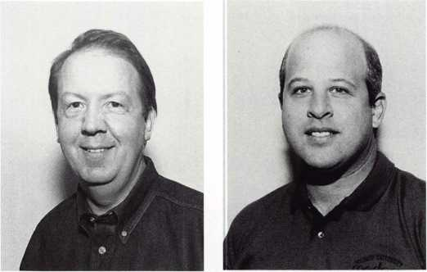

Keith D. Johnson Michael Katz

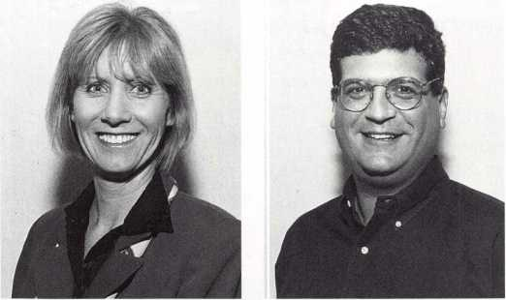

Susan Lawless David Kitchen

Medeco High Security Locks recently named four new Account Executives. These four executives will be responsible for the company’s sales and marketing efforts in the following areas: Keith D. Johnson, Houston; Michael Katz, Los Angeles; Susan Lawless, Central and North Florida areas; and David Kitchen, southwest United States, including Arizona, New Mexico, western Texas and southern Nevada.

regions

The Central & Southern Colorado Locksmith Association (CSCLA) is holding its regular meeting on March 19 at 7 p.m. and will have E Primus Certification at Acoma Locksmith Service on March 20.

The new line officers for the Locksmith Association of the Washington, D.C. area are: President, Robert Smith; Vice- President, James Mullins; Secretary, Michele Phillips; Treasurer, Tom Schwarzkopf; and Sergeant at Arms, John Speakes.

The Fox Valley Chapter will hold two safe classes on March 6 and 7. March 6 will feature “By Pass by Lockmaster” taught by Brian Lamb, CPS. It will focus strongly on safe lock manipulation. On March 7, there will be a class on Safe Moving sponsored by the Indianhead chapter.

(Editor’s note: Would you like to see your regional association’s activities represented in Keynotes? Just fax all correspondence to 214-827-1810 or email to: [keynotes@anet-dfw.com](mailto:keynotes@anet-dfw.com).)

14 | Keynotes March 1999

• obituaries

ALOA would like to offer its condolences to the families and friends of the following members who recently passed away.

William Elley, 38, of Key-Rite Security Lock & Safe in Denver, Colo. He was a member for six years.

James “Jim” Johnson, 57, of Pro-Tek Lock & Safe in Hindsdale, 111. He was a member of ALOA for 23 years.

Larry A. Scheuer, 53, co-owner of A-l Lock and Key in Warsaw, Ind. and was a member of ALOA for 12 years.



prp

CRL

Derwin C. Sutphin, Blacksburg, Virginia

To err is human

We at Keynotes occassionally allow an error to slip by us. Here are two corrections from past issues:

In “The Abus Diskus Now Rekeyable Padlock” article (Keynotes, January 1999), it read that the hasp was “designed for” the different versions of the 70 mm and 80 mm padlocks. It should have also read that it was “suitable for other lock series” as well.

Also in the January issue, “Best Type Interchangeable Cores,

Part 2” was featured incorrectly. The correct chart is as follows.

|  |  |  |  |
| --- | --- | --- | --- |
| Number  Value | Bottom  Pin | Top  Pin | Key  Depths |
| □ | . 1 1 □ | - | .3 1 B |
| 1 | . 1 22 | - | .3 □ 5 |
| 2 | . 1 35 | .□25 | .293 |
| 3 | . 1 47 | .□37 | .2BD |
| 4 | . 1 SO | .□ 5D | .268 |
| 5 | . 1 72 | .□52 | .255 |
| 6 | . 1 B 5 | .□75 | .243 |
| 7 | . 1 97 | .□B 7 | .2 3 □ |
| B | .2 1 □ | . 1 □□ | .2 1 B |
| 9 | .222 | .112 | . 2 □ 5 |
| 1 □ | - | . 1 25 |  |
| 1 1 | - | . 1 37 |  |
| 1 2 | - | . 1 50 |  |
| 1 3 | - | . 1 52 |  |
| 1 4 | - | . 1 75 |  |
| 1 5 | - | . 1 S7 |  |
| 1 6 | - | .200 |  |
| 1 7 | - | .2 1 2 |  |
| 1 B | - | .225 |  |
| 1 9 | - | .237 |  |

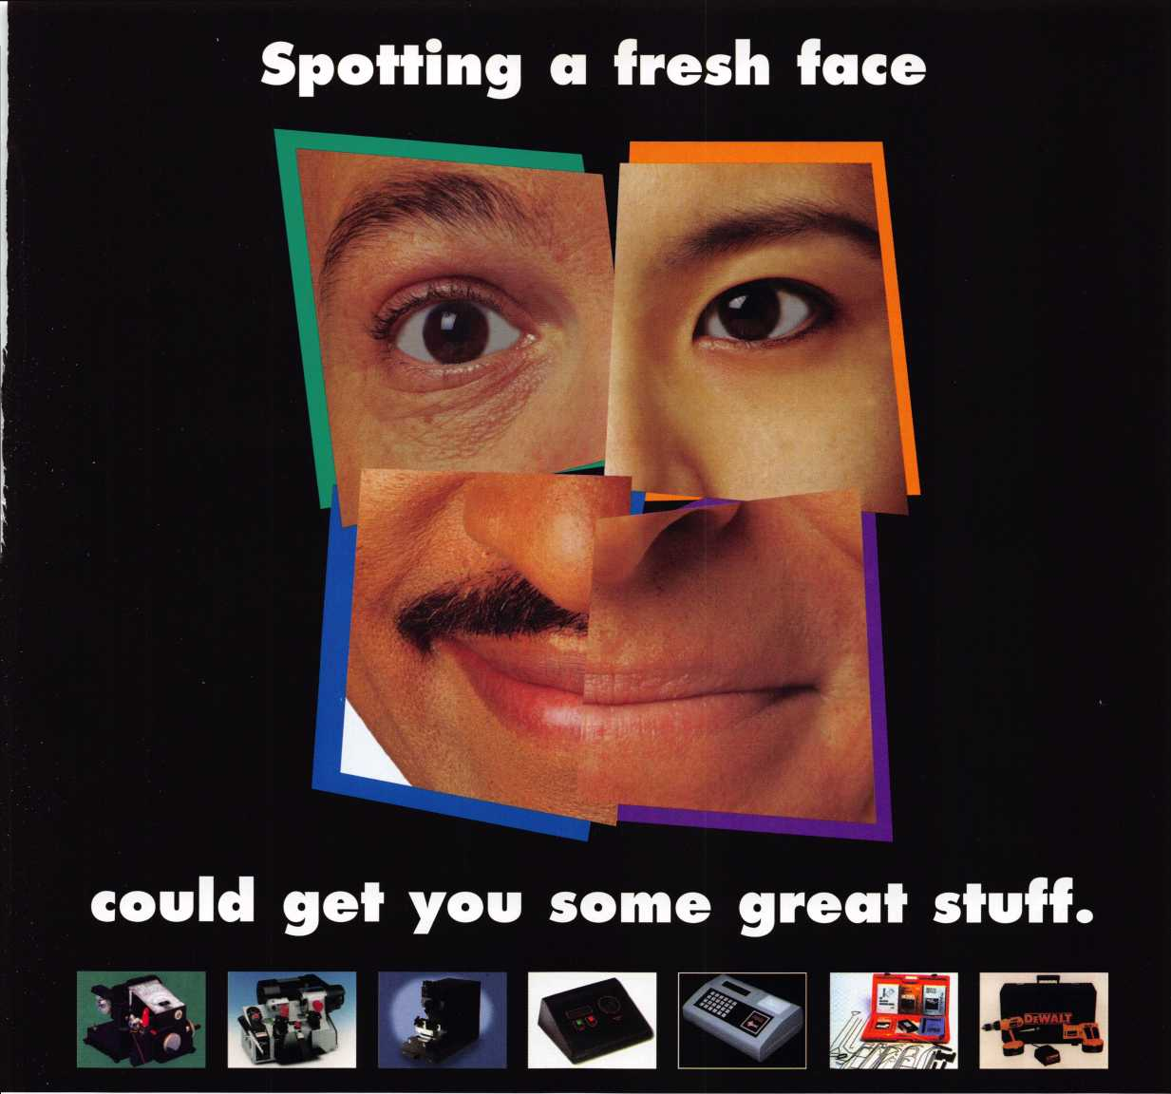

Facing Facts

Do you know what happens when you sponsor an individual for membership in your national association? You strengthen the voice of the industry and you help another locksmith along the road to complete professionalism.

As an added bonus, for each member you sponsor during 1999, you will receive $40 in Convention Bucks (good for ALOA registration, classes, goods and services at ALOA '99 or ALOA 2000),

and an entry in a drawing for one of several incredible prizes, some valued up to $2,199!! You could be the winner of a: Rytan RY100 Duplicating Machine, HPC1200 Blitz Code Machine, Silca Bravo USA Duplicating Machine, Framon Sidewinder Duplicating

Machine, JET ETD-1 Transponder Key Decoder Kit, Silca RW2 Transponder REader/Duplicator, High Tech Tools Pro Lockout Kit or a DeWalt 18V 1/2" Cordless Hammerdrill and Reciprocating Saw Set!

Keep An Eye Out

Everybody wins when you spot that next ALOA member. Let's put our noses to the grindstone and enter the next century with a larger, stronger membership. You can get a copy of ALOA's membership application on our web page at [www.aloa.org](http://www.aloa.org) under "Joining ALOA,"or by calling 1.800.532.2562.

Sign up a friend today, and send us their photo so that we can include them in future ads!

What ALOA Board Positions Are Open  
and Where Am i Qualified to Run?

There are currently six regional director positions open for election in addition to the position of President. ALOA members now elect the directors from their own regions. Only ALOA members from a region are elegible to run for the open position(s) in that region. And only members from the nominee s region will be receiving a ballot to vote for that candidate. Members from any region are eligible to run for the President s position. You must have been an ALOA member for at least three years to run.

The following vacancies will exist for the election to be held before the ALOA ‘99 Convention.

Southeast two directors

North Central two directors

Southwest two directors

President

If you have any questions, please contact Charles Gibson at (800) 532-2562 or email [charlie@aloa.ioffice.com](mailto:charlie@aloa.ioffice.com) Below you will find the required nomination petition and on the opposite page, there is the actual nomination form.



Associated Locksmiths of America, Inc.

Board of Directors Nomination Petition

Please print legibly or type. A total of 25 signatures are required.

This form can be reproduced if needed.

I, the undersigned, request thatbe placed on

(name of nominee and member number)

the ballot forfor the election to be held at the

(position for which individual is being nominated)

special meeting of ALOA members to be held in 1999 or any adjournment thereof. I am eligible to vote in theregion.

|  |  |  |
| --- | --- | --- |
| PRINTED NAME | MEMBER # | SIGNATURE |
| PRINTED NAME | MEMBER # | SIGNATURE |
| PRINTED NAME | MEMBER # | SIGNATURE |
| PRINTED NAME | MEMBER # | SIGNATURE |
| PRINTED NAME | MEMBER # | SIGNATURE |
| PRINTED NAME | MEMBER # | SIGNATURE |
| PRINTED NAME | MEMBER # | SIGNATURE |
| PRINTED NAME | MEMBER # | SIGNATURE |
| PRINTED NAME | MEMBER # | SIGNATURE |
| PRINTED NAME | MEMBER # | SIGNATURE |
| PRINTED NAME | MEMBER # | SIGNATURE |
| PRINTED NAME | MEMBER # | SIGNATURE |
| PRINTED NAME | MEMBER # | SIGNATURE |

|  |  |  |
| --- | --- | --- |
| PRINTED NAME | MEMBER # | SIGNATURE |
| PRINTED NAME | MEMBER # | SIGNATURE |
| PRINTED NAME | MEMBER # | SIGNATURE |
| PRINTED NAME | MEMBER # | SIGNATURE |
| PRINTED NAME | MEMBER # | SIGNATURE |
| PRINTED NAME | MEMBER # | SIGNATURE |
| PRINTED NAME | MEMBER # | SIGNATURE |
| PRINTED NAME | MEMBER # | SIGNATURE |
| PRINTED NAME | MEMBER # | SIGNATURE |
| PRINTED NAME | MEMBER # | SIGNATURE |
| PRINTED NAME | MEMBER # | SIGNATURE |
| PRINTED NAME | MEMBER # | SIGNATURE |

161 ***Keynotes***

March 1999

YOUR COMMITMENT TO ALOA BOARD SERVICE

(Please read carefully and sign where indicated.)

The responsibilities of an ALOA board member include contributing a moderate amount of personal time, and a significant degree of professional guidance and expertise to the organization.

You will be expected to come to board meetings, and the annual membership meeting, prepared to sensibly discuss matters of great importance to your profession and prepared to set policy as part of a governing body. Your course of action during your tenure on the ALOA board should be guided by fairminded, constructive and achievable goals pertaining to mat­ters of consequence for ALOA and for the industry. Your contributions are expected to bene­fit ALOA as a whole, taking individual member rights and concerns into account, but free of the taint of partisan politics or personal gain.

On a practical note: ALOA board members are expected to behave and dress professionally at all times, especially when actively representing the association. ALOA board members are required to participate in two board meetings per year, of three to four days in length, one each fall and spring. Board members are also asked to attend the annual convention and are required to attend the annual membership meeting. Board members may also be asked, on a voluntary basis, to represent ALOA at related local, state or regional functions, including serving in the ALOA Booth and otherwise promoting ALOA. When travel is required for a board member, expenses covered by ALOA include lodging, travel and a rea­sonable **per diem.** The Board has stipulated that assigned travel will be reimbursed at the lesser of the 30-day advance tourist class airfare in effect at the time of travel or the current per-mile rate for travel by personal automobile. Spouse expenses, including extra room

charges, etc., are the individual’s responsibility.

* * *

I have read and understand the above responsibilities of an ALOA board member, and agree to commit my time and energies as needed. I certify all of the information contained on this form and supporting documentation to be true and complete.

I can be contacted with questions at:

Address Phone #

Signed: Date:

Please attach a recent photograph of yourself and retain a copy of this profile for your own files. This profile and all supporting documentation should be submitted no later than April 1,1999.

Mail to: Nominee Profile

Secretary of the Board of Directors  
Associated Locksmiths of America  
3003 Live Oak Street  
Dallas, TX 75204-8186

REV. 7/98

March 1999

Keynotes



If you’re thinking about running your own lock shop, then Jim Rushing has a little advice for you. No, make that a LOT of advice.

Much of which can be heard in the various classes he teaches on the subject (including the ALOA Continuing Education (ACE) course, “Starting Your Own Locksmith Business”).

Rushing, an ALOA member for 13 years, currently owns and operates Barksdale Key and Lock Service in Bossier City, La. Among the other ventures he owns are Q&R Service Corporation and Southern Locksmith Training Institution. He also retains an interest in the Professional Lock- smithing Institute.

These days, he’s enjoying a reasonable amount of success with his lock shop. In doing so, he’s learned several hard yet valuable lessons about running a business the right way. Unfortunately, these lessons weren’t via an ACE course, but rather through tough experiences. Nonetheless, he’s pleased that he can pass this information on to other locksmiths who have aspirations of becoming business owners.

After all, much of what he instructs may come as a complete surprise to most would-be entrepreneurs. Even some of the most basic aspects of opening a business shocked him when he opened Barksdale.

“I guess, my biggest surprise was having to pay taxes when I hadn’t even collected them,” he says. “I remember when I started off with my shop and at the end of the month, I owed about $400 or $300 worth of taxes and I hadn’t even collected them yet. I found out that it didn’t make any difference because I still had to pay them and collect them when I could. In most cases, if you don’t collect, then you’re never going to get your money back from the state.”

According to Rushing, such tax dilemmas are among the biggest surprises for first-time business owners. He says that the vast difference in utility bills (residential vs. commercial business) is another thing that shocks most people.

-L Keynotes March 1999

“Some people may think that because it costs $60 to have the water or gas turned on at home it will be that way at their place of business. If you’re a commercial business it’s around $200. They also don’t realize that a business telephone costs about three or four times as much as a home telephone. Usually a home phone costs $22.50 a month plus long distance charges, but if you get a business phone, it more than doubles.”

Outside of these unexpected spendings, another thing most people take for granted when starting a business is its location. Rushing advises everyone to research a site prior to setting up shop. After all, if a certain space has been the home for numerous businesses in a short span of time, then that particular location may be the reason they either moved away or failed.

“You may have heard of some cheap property where several businesses have been in and out of within eight or nine years. That’s because it’s a bad location. It doesn’t matter who goes in there next, chances are, they’re going to fail,” he says.

He also points out back-up capital is an additional factor that gets overlooked in the start-up process. Often times, new company or store owners don’t realize the importance of an “accounts receivable” system for commercial customers. Rushing adds that if a business can’t withstand $10,000 - $15,000 in accounts receivable for 30-60 days, then end-of - the-month taxes/bills will be difficult to pay.

Registering your business name is also taken for granted by many people. Some people blindly choose a familiar yet generic title such as “A-l,” but if another shop has registered that name, then you may find yourself out of business and faced with legal problems.

Outside of his class, Rushing says an excellent reference for informa­tion is SCORE (Service Corps of Retired Executives), which works with the Chamber of Commerce in many cities. The organization, which is sponsored by the Small Business Administration, hold meetings that

detail the finer points of sales, maintaining a professional appearance, keeping an eye on customer scams, avoiding financial pitfalls and numerous other helpful tidbits.

“They (SCORE) will even send a person out to your business for free,” he says. “He’ll see what your problems are and help you straighten them out. All of these people that make up this organization are retired execs who have been very successful. They’re not fly-by-nighters. They’ve been bankers, department store managers, pharmacists and such. It’s a great source.”

He adds that consulting with SCORE is essential in acquiring a Small Business Administration loan. Before the SBA will even conceive of approving a loan, it requires an official business plan detailing who your competitors are, how much start up money you have, who your customer base is, where you’re going to receive supplies from, your expected profits and more. Without that information, the chances of receiving a loan are diminished considerably.

Rushing started with a mobile shop in 1977 after retiring from the military. A year later, he opened up Barksdale. He says he started out with $10,000, which he thought was a lot of cash at the time. After spending money on all the aforementioned expenses and purchasing some used equipment, all of that money was gone. Now, 21 years later, Barksdale Key and Lock Service is prospering in the same exact spot and his first dollar sits proudly in a glass frame.

Upon opening his shop, he went about placing an ad in the Bossier City Yellow Pages. This was yet another unanticipated cost that took him by surprise.

“I asked how much a Yellow Pages ad was and they told me it would be $600” he says. “I said, ‘$600 a year! That’s not bad!’ Then they said it would be $600 a month! The local newspaper costs about that much and

is not near as effective. If you don’t advertise, nothing’s going to happen. You’re not going to get business.

“If you’re like me and open your business at the beginning of the year, you have to wait until the next year for your ad to appear. So, you have go around and hand out business cards until the next yellow pages come out. And if you place an ad and can’t pay for it, then they take your phone number away from you and you can’t get it again!”

After learning the ups and downs of starting and running a successful business, Rushing used his experiences to develop his business classes. When he began teaching, he said he met with opposition from many shop owners who thought that he. was influencing their employees to quit and start their own businesses.

Such wasn’t the case. Rushing says that 99 percent of his students remain employees after learning the often harsh realities of becoming a business owner.

“When you come to my class, you may leave and be happy to be an employee after you find out what’s involved, what the pitfalls are, what the costs are and what the risks are,” he says.

Rushing isn’t trying to scare anyone away from starting a business. He’s merely enlightening them to what awaits each and every one of them. So, if it’s so tough, why did he start his business? He sums it up quite eloquently.

“It’s the American Dream,” he says. “To own your business, you have the chance to advance it and to make more money, but it takes a lot of hard work and several years to do it. You’ve got to set a goal and stick with it. At times, you’ll work longer and harder than you ever did in your entire life for less money. I find it extremely rewarding. As I said,

It’s the American Dream.”

March 1999

Keynotes

**THE SOURCE FOR...**

**Features**

**Timelocks**

Diebold 127R and Mosler 126R

Replacement Movements

**✓Custom designed to retrofit most Diebold and Mosler timelock cases ✓13 jewel Swiss movements ✓Heavy duty gear train**

**✓Beautifully finished plates with captive mounting screws ✓Kumahira, Yale and LeFebure versions available**

**Regular Price $225 Sale Price $199.95**

*Sale Ends March 31,1999*

*\*

**!M| Time-Master.com (web) • [timstr@AOL.com](mailto:timstr@AOL.com) (email) • 888 798 8464 / Fax 800 798 8463 • 785 232 8705 / Fax 785 232 2603**

19

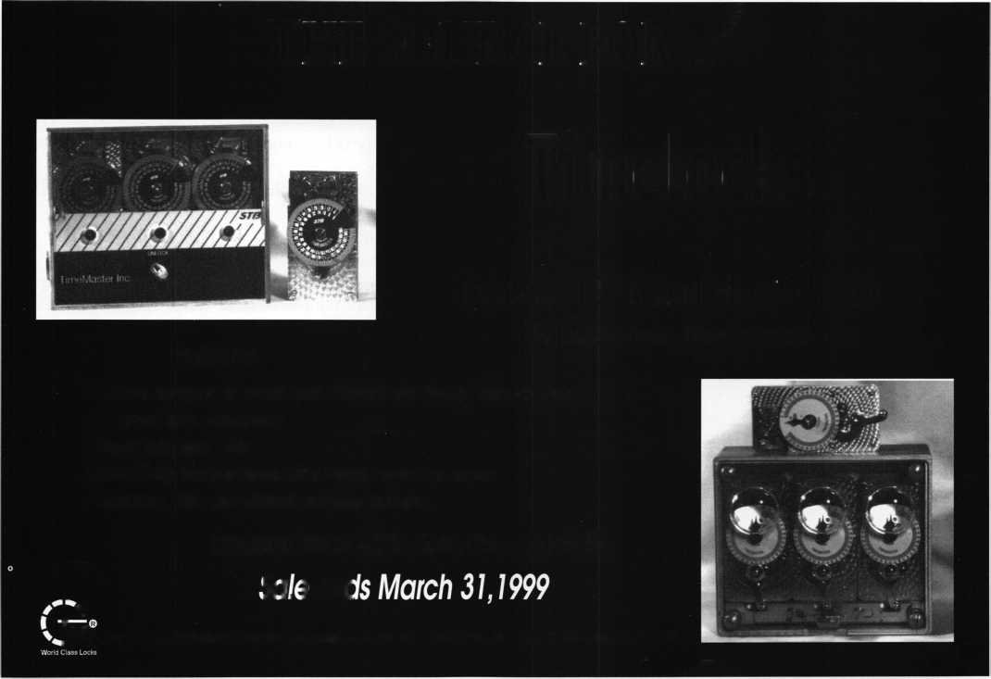

Most of us never have enough time to get everything done. We  
work harder, we work longer, but feel like were not forging ahead. So  
we go to work earlier, stay later, perhaps work on weekends. Finally,  
when we go home, we’re worn out, and don’t feel as though we have  
much time, if any, left to ourselves, or to spend with our families and  
friends. Does this sound familiar? Then read on.

To obtain the most use of our precious time, we must use good  
time management skills to attempt to get organized. Many of us  
spend a good deal of time using computers for both work and home  
tasks. This is an ideal place to start our quest to regain some time.

Our goal should be to work smarter, not harder. To get started, here  
are a few computer shortcuts that should help work faster and more  
efficiently. By using some of these computer-related suggestions,  
hopefully, you’ll gain some time.

When using a computer, the shortcut possibilities are endless. Of  
course, the more computer-related knowledge and technical expertise  
you possess, the easier it will be for you to perform tasks quickly and  
efficiently. You will also find that your own creativity and imagina-  
tion will help develop your own set of shortcuts.

LISTS

Does your shop area have piles of paper everywhere - on the desk,  
on the chair, on the floor, on sticky notes applied to the walls and on  
the telephone? Perhaps some of these papers contain business cards,  
lists of supplies to be ordered, follow-up tasks, or lists of projects to be  
accomplished. Do you spend time looking for an E-mail address, a fax  
number, etc.?

Begin to organize! Go through all of the papers, one piece at a  
time. Make piles of similar items. Perhaps during this process, you  
will find there were even some papers you didn’t need!

The next step is to create different lists on your computer. This can  
be done simply using word processing software, spreadsheet software,  
or more sophisticated database or contact manager software.  
Remember that proper planning is necessary to insure that the list(s)  
you create will be of value to you now and in the future.

For example, a first list could be started for “Things to Do”. This  
list could include just a few columns (i.e. date, task, customer).  
Another list could be created for parts to order. This list might  
include part number, customer, date ordered, and supplier.

Another list to compile using your computer could be a complete  
list of customers and business contacts. When you develop your  
system, it is essential to keep your lists up-to-date. Otherwise, you  
end up where you started -with piles of paper and lost time spent  
looking for the proper information. Whenever a telephone number  
changes, you just make the change to the record. With a few clicks of  
the mouse and a few keystrokes, you can update your list or customer  
records. You will be able to add more customers, potential customers  
and business contacts to your list or remove them. Additional pieces  
of information can be added to this database such as E-mail addresses,  
fax numbers, hardware brands, primary contacts or future expansion  
plans. Once the business contact/customer names are recorded, you  
can use them for your mailing lists, phone lists, etc. While you’re  
compiling this data, this may not seem like a shortcut. But once  
done, there will be far less searching for data.

When a new item for one of your lists comes in, don’t drop  
everything else. Plan to add/delete items in a timely fashion so that

SHORTCUT:

these items don’t build up again. Don’t forget to delete completed items or names that you  
will no longer need! Try to check your “to-do” lists daily when you come into the shop, and  
before leaving.

FILE DIRECTORIES/SUBDIRECTORIES

If you use a computer hard drive or peripheral storage devices, this is no more than an  
electronic filing cabinet. And no matter how large a hard drive you’ve got, if you continue to  
add more and more files and software programs without deleting the ones you no longer need  
or use, the drive, like the file drawers in your file cabinet, will eventually become stuffed  
beyond capacity. Do some housekeeping and clean out those directories or create a logical  
system to organize your files. Subdirectories can help eliminate the long, arduous searches for  
files that you have created.

Some programs will allow you to use three character extensions as a method of trying to  
identify different types of files. For example, use .doc, dtr, .pro, .mem for document, letter,  
proposal, memo. Some of the newer software allow you to use long descriptive file names. It  
makes sense to set up separate directories and subdirectories that can be used to store similar  
types of information. When you set up your directories/subdirectories in a logical, systematic  
manner, you’ll save yourself hours of search time in the future. If you have a large customer  
who generates a lot of correspondence, set up a separate directory for that company and don’t  
mix these files with any others. If you have different kinds of files for this customer, i.e. master  
key systems, letters, proposals, etc., you might want to set up subdirectories under the  
customer name.

Also, being familiar with search techniques, such as looking at files chronically can be a  
shortcut to find a particular file. In the process of organizing your subdirectories, you may  
want to rename files or subdirectories to more logical names.

UPGRADING SOFTWARE

of your favorite software program releases a new version, you may

consider buying the new version. These bells and whistles will help you get your work done  
quickly. And that’s why we use computers, because we want to produce high-quality work  
and have a little free time for ourselves!

And while we’re on the subject of new software, make sure to conspicuously write the serial  
number and technical support numbers on instruction manuals so that they are quickly  
accessible.

TRAINING

The software we purchase can help us more and more to mn our businesses; however many times we are not using the software to our full advantage. One of the reasons is that we are not fully aware of all of the software’s capabilities and shortcut features.

Training centers offer one-day, evening and weekend courses. A day devoted to learning new software can be extremely beneficial.

There are numerous video training tapes available for hundreds of different software packages. Sometimes, several hours invested in watching these videos can pay dividends in time.

For example, the techniques for copying and pasting can save much time in repetitive typing. Knowing some basic formulas in spreadsheets can help you perform numerous calcu­lations quickly and accurately.

SHORTCUT MEETING

Here’s an idea for an upcoming locksmith association meeting. Have each member bring to the meeting his/her best computer shortcut that they have found. Since everyone is in the same business, you will most likely pick up some helpful hints to enable you to become more time efficient.

All of these computer-related shortcuts may seem like LONGcuts in the beginning, but with the goal of becoming more time efficient, they may save you endless hours of time.

SHORTCUT:

SHORTCUT:

| SHORTCUT:)

v- 8

Whenever the developer

SHORTCUT:

**STRATTEC TECH**

**Q**

WHEN OEM EQUIPMENT  
INCLUDES ADVANCED  
ELECTRONIC ENGINEERING,  
DOES THE LOCKSMITH  
NEED COSTLY, SPECIALIZED

TOOLS TO PROVIDE OEM  
QUALITY SERVICE?



NOT NECESSARILY. WITH THE MRD SYSTEM, FOR INSTANCE, RE-KEYING IS UNCHANGED, AND THE VEHICLE'S ONBOARD COMPUTER REPROGRAMS ITSELF AFTER LOCK REPLACEMENT.

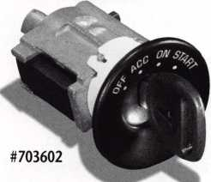

Now standard equipment on over 20 popular General Motors nameplates, the STRATTEC MRD system works to effectively disable vehicle ignition if the lock cylinder is forced or turned with anything but a correctly cut key. A small coded magnet is permanently imbedded in the side-bar cylinder, and a magnetic sensor is mounted in the case assembly. When the cylinder rotates, the sensor registers the mag­net's proximity and signals the vehicle's onboard computer. The vehicle is permitted to start. Forcing the lock breaks the magnet, disabling the ignition. Since any correctly-cut key will start the vehicle, no special tools or skills are required for service. So this high-tech security system is simple to work on.



**STRATTEC**

For more information, please  
call your STRATTEC authorized  
wholesale lock distributor



March 1999

Keynotes



B

aker’s Security Solutions in Houston, Texas is one of the city’s  
largest lock, safe and alarm companies. The owner and  
president, Randy Simpson CML, has implemented several

visionary changes to the business since purchasing the company seven  
years ago. His new business management software is just one of his  
far-sighted innovations. A brief review of the recent history of this  
company will help us see why modern computing became critical.

Baker’s Safe and Lock was founded in 1970 in a tiny building located just a few feet away from the current site in southwest Houston. In 1971, a retired NASA Engineer, Dana Enos, came to work for Mr. Baker and two years later, he bought the business. In 1979, Dana hired an eager young locksmith named Randy Simpson and they worked closely together for the next 13 years. During this period, Baker’s built a solid reputation and a loyal customer base. The business averaged five full-time employees and typically did a quarter million dollars in annual sales.

When Randy took over the business, he began an aggressive growth program. Total sales have increased 730% and the company now employs 25 full-time people. They have taken over the entire 3800 square foot building, remodeling several times to achieve the right mixture of retail space, storage, offices and technician workspace. The front counter does a steady business servicing walk-in trade as well as handling a solid will-call business selling to area contractors and facilities maintenance people. The sales floor is designed primarily to showcase a variety of safes from Amsec and Sentry.

Baker’s has invested a lot of time and resources into building an electronic security expertise. Presently, the company is divided into access control divisions/CCTV, alarm systems, fire alarm and hardware. The three electronic divisions have a total of six field tech­nicians, while there are nine service trucks devoted to hardware/lock- smithing.

Randy believes in identifying the type of customer you want to target and focusing your attention on finding and keeping those accounts. The Baker’s target account is one who has the potential to produce a recurring revenue opportunity for the business. Several companies have entered into service contracts where all lock and hardware services are provided for a fixed cost. For one account, a full­time locksmith is stationed on site 40 hours a week to care for their needs. In another case, a major retail chain paid consulting fees for professional help in finding a loss prevention solution to their cash management problems.

All business decisions are based on maximizing target accounts. With this in mind, Baker’s has chosen not to accept any outside automotive work. They refer all calls for lockout service or road repairs to a neighboring locksmith shop. There are other types of work that Randy has concluded are best handled by top-quality subcontractors. For example, one company is used for all safe

22

Keynotes

March 1999

deliveries and moving jobs. Another locksmith is called for any significant safe lockout calls. These are services that Baker’s could handle, but experience shows that the workforce is more efficient and scheduling is more consistent when outside experts are used for these specialized, time-consuming tasks.

Targeting high end commercial business requires different marketing practices. In the fourth largest city in the U.S., where several competitors take out full-page or two-page ads, Baker’s spends only $185.00 per month on Yellow Page advertising. Instead of phone book ads, Baker’s spends money on outside salesmen, profes­sionally prepared presentations, attractive service vehicles and uniforms.

The challenges of managing 15 outside service technicians, hundreds of regular accounts and hundreds of thousands of dollars in equipment purchases made it apparent that a comprehensive business management software solution was needed. Adding urgency to the quest for a better program was the fact that their “GOFER” dispatch program would be unable to work correctly beginning in January of 1999. What was needed was a new program that could do everything “GOFER” did, only better, and which could seamlessly incorporate every other function of managing the business.

Enter Rick Myers and United Business Computers of Yorba Linda,

Calif. Mr. Myers was previously a major part of the American Lock

**lousiness Grow Modern Softw**

and Supply organization and a long-standing friend of Randy’s. UBC had developed business software that automates and integrates most of the major business functions performed in a retail environment. Randy decided to become one of the first three locksmith businesses in the country to adapt this program to his operation.

The total package is made up of three modules. The first to be implemented is a job dispatch and invoicing program. Phase two will incorporate inventory and purchasing. The final module will bring all accounts payables into the same package. The idea is that, rather than being separate functions, dispatching, order processing, inventory management, accounts receivable and accounts payable are really just different steps in one process. This process is repeated over and over every business day. Duplication of effort in one or more of these areas can become a major drain on a business’ resources.

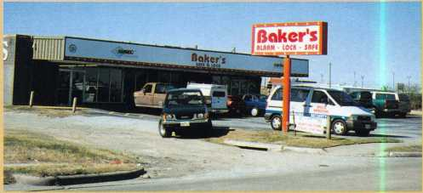

Baker’s Security Solutions, Houston, TX.

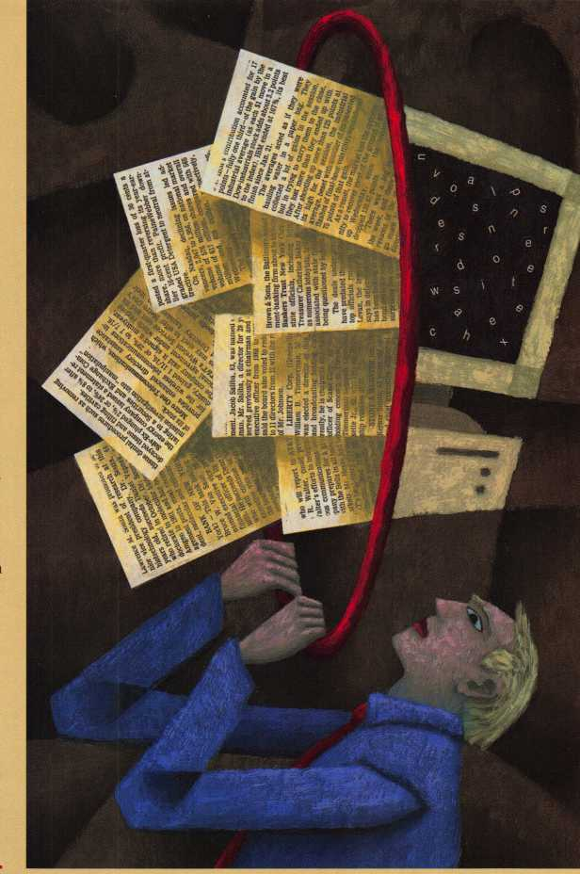

**th Requires  
are Solutions**

**By Paul F. Chandler, CR1**

Implementing the first phase involved customizing the basic  
package to the specific needs of Bakers operation. Data had to be  
entered for all existing accounts. One of the great features of this  
program is that each customer can have a pricing profile entered that  
will consistently set mark-ups and labor rates regardless of which  
sales representative or technician enters the job. Building a detailed  
database on each account will allow Baker’s to provide employees  
with accurate information and history on every customer. That same  
information can be used proactively to target products and services  
that meet the specific needs of customers. An old adage in business is  
that “if you can’t measure it, you can’t improve it.” The information  
that this program will store and measure can have a major impact on  
the direction Baker’s takes in years to come.

Scheduling 15 service techs is a daunting challenge, but the UBC  
program makes it easy. A “job board” allows the dispatcher to see at a  
glance who is free and who is not. Each job is entered as the call comes in  
and the system keeps track of it until it is complete. According to Kevin  
Pering, Customer Service Manager, the best thing about the new system  
is that “nothing can slip through the cracks.” A customer who has  
requested service can call anyone in the office and find out instantly wher  
the job is scheduled, whether parts have been ordered and which  
technician has been assigned to do the work.

UBC works closely with Baker’s implementing and adjusting the

program to fit their needs. For example, the day I visited the office, Randy had discovered that the system could not invoice a single line item over $9,999-99. The designers had assumed that no single line items would ever exceed $10,000, but they were wrong. Baker’s had a $50,000 engineered security system that they needed to invoice and they did not want to break it down into component parts. UBC promised to fix the problem. Using modem access, UBC program­mers entered the program and implemented the changes overnight and the next day the problem was fixed.

Baker’s computing needs were growing in other areas at the same time. As an “IdentiCard”dealer, Baker’s needed to provide access control software support for customers using Windows NT. Randy decided to implement NT throughout his operation. He was also prepared to use the Internet more and more in the future. Instant

Internet access at every workstation was a priority. To accommodate these goals, as well as to host the UBC program, Baker’s invested in state-of-the-art hardware. The new server has a 400 megahertz Pentium II processor while the desktop units have 300 megahertz processors. Dual hard drives in the server ensure that no data will ever be lost. A nightly backup of all accessed files is made as well. A Shiva Access Port connected to an ISDN line allows simultaneous access to the Internet from every desktop. Peripheral equipment includes a high speed laserjet printer and scanner.

My tour of Baker’s Security Solutions impressed upon me the significance of locksmithing in the “Information Age”. I’m sure some readers are shaking their heads saying, “I can’t afford to spend that kind of money on computers.” According to Randy Simpson, they can’t afford not to.

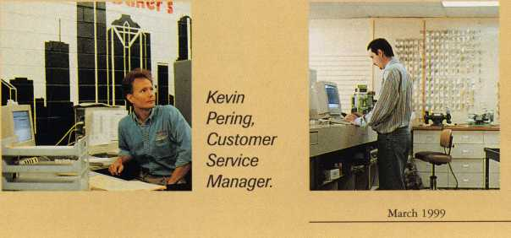

Randy Simpson, President of Baker’s.

Point-

of-Sa/e

Computer

System.

Keynotes

MU

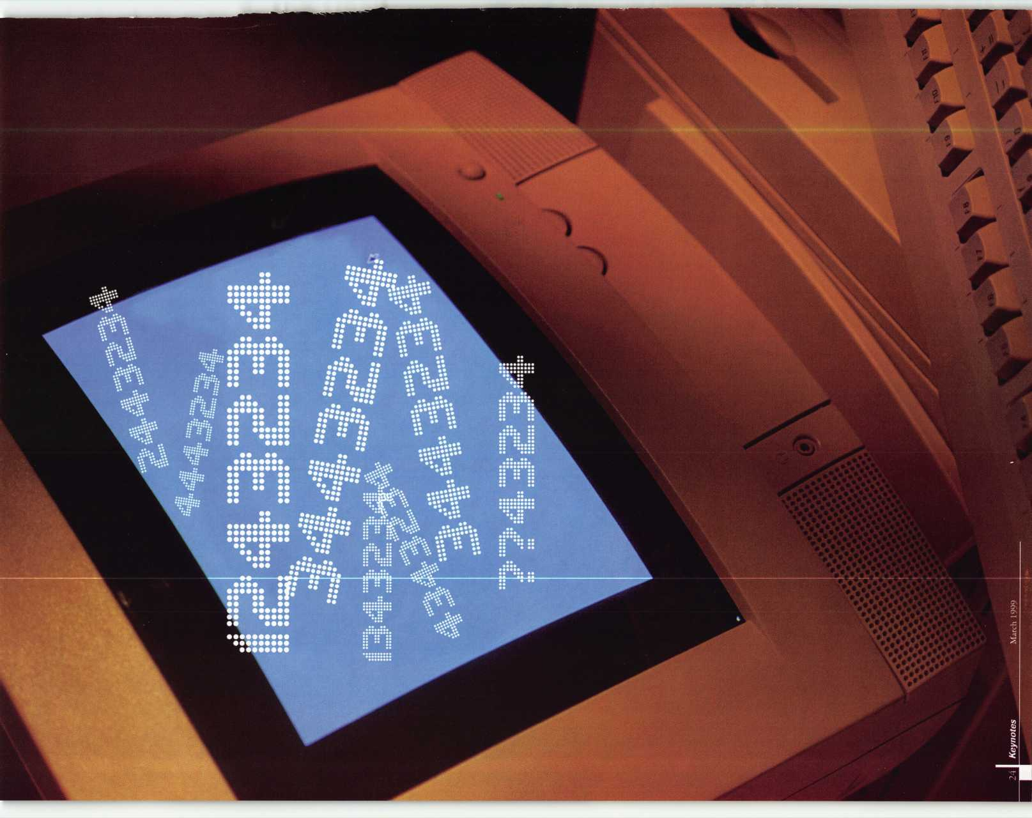

I

When most locksmiths think of car keys and computers, they probably think of the various code programs that are sometimes used in place of printed codes (in book form). You usually start out with a code number, either from a lock or recorded information. With code books, you first look through the printed index and track down the volume and page to find where the particular code is located. After a few minutes, you find the code. If the code number can be found in another code series, and the first code series you found was wrong, you would repeat the process and check out the alternate code series until the correct code is found. Finally you would have the information needed for generating an operating key for your lock.

When using computerized codes, the process is similar but faster. You would type in the needed code and wait for the information to appear on your computer screen. Depending on the code program and your computer’s processor, it might be a several second wait or merely a fraction of a second. If there are two or more similar code series that match your code number, you may have to sort through them to find the correct one. Regardless, any code program should have an answer in not much more than a minute, definitely faster than using code books.

Beyond being faster and easier to use than code books, many code programs integrate additional features not possible with printed codes. Instead of entering a

code number to find the proper key cuts, you can enter the key bitting (or part of it) and let the program search for the code number or numbers that match. Using codes in reverse isn’t a practical option with printed codes, but it can be a simple task for a computer. When those search functions are included with your code program, you either use the feature or not. When you have to buy a separate program to access those features, you need to justify the price with a practical use for those features.

Blackhawk computerized codes (Codes On Disk- COD) cost less than most of the other code programs, but the reverse code search functions are not included in the basic code program. You have to buy separate programs from Blackhawk to accomplish those tasks. When you combine the cost of the free standing separate reverse code search programs, the price of the Blackhawk codes is nearer to the prices of the competition. Blackhawk has two specialty code search programs for automotive use. They are Reverse Auto Codes (RAC) and FILL (Fill the Combina­tion). The way that you use (or don’t use) those search functions will help you determine what might be best for you.

Reverse Auto Codes (RAC)

Reverse Auto Codes (RAC) involves inputting a key bitting pattern, and letting the program find the matching code number(s). RAC is a windows based program and will work with Windows 3.1 or greater, on an IBM compatible

computer (386, 486, Pentium, etc.) with a hard drive. RAC uses about three megs of space. This program has the greatest value for the serious automotive locksmith, but can be useful even if you do just a small amount of auto lock work. You can provide a service for your customers who either never had the code numbers to go with their car keys, or lost the codes and have no practical source for tracking down the code numbers. After manually decoding their car keys, you can input the cuts and get the proper code numbers for them to store away safely in case all their keys are ultimately lost.

Photo 1 shows the opening screen for the program. I entered the combination 12345, and got the results in photo 2. It is a list of all the auto codes with that

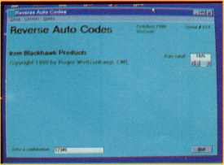

Photo 1

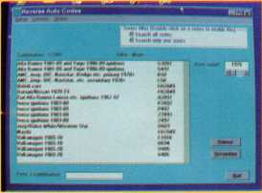

Photo 2

March 1999 ***Keynotes*** L



particular bitting pattern, regardless of car brand or key blank number. There are 17 different code numbers.

If you would like to limit how many different codes are listed, there are a number of ways to filter out some of the codes and have much less clutter on the screen. Off to the right side of the screen and above the middle, it says “Date cutoff.” In the box next to it is: 1925.

That is apparently the default setting. It can be switched to any year up to 2050. Any code series that shows an ending year before that year will not be listed. In photo 3, you can see how the list shortens when the year is changed to 1974. Now only 12 codes are on the list. The codes ending in 1970 and 1973 have been eliminated from the list.

Photo 4 shows the date cutoff of 1990. The list has been shortened again to five. The seven missing codes have ending years of 1987, 1988 and 1989- The codes remaining on the list have no ending year indicated, and would remain even if you changed the year to 2050. In the top right corner of the screen, it says: Series filter (Double click on a series to enable this). If I double click on the series “AMC, Jeep, IHC, Navistar, Dodge etc. primary 1970+,” and then re-input the combina­tion: 12345,1 get the screen in photo 5. If

I had a number of key combinations from this same code series, I could enter a new key bitting pattern and only get matching code numbers from this series.

Near the bottom right hand portion of the screen are two boxes labeled:

“Primary” and “Secondary”. This is another type of code number filter, but the terms don’t mean primary (as in ignition key) or secondary (as in trunk key). This portion is controlled in settings, and allows you to pull out some of the more obscure code series and put them in the secondary category. Your search could then be limited to more common codes in your primary list, or switched to secondary to find older or more obscure code series. The primary and secondary lists can be modified as needed, if you find certain code series more or less common than expected.

Entering the six digit combination: 354424, brings up a huge list of six cut GM code series in photo 6. The arrow on the screen points to the scrolling bar. There are about 10 more codes not showing on the screen, that can be seen by scrolling downward. There is an additional filter for GM six cut keys. On the far right of the screen toward the middle, you can select a GM keyway. Choosing the “A” keyway, I get the more

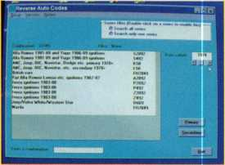

Photo 3

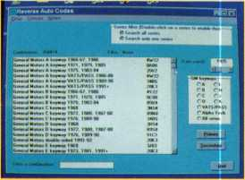

Photo 6

Keynotes

March 1999

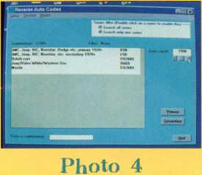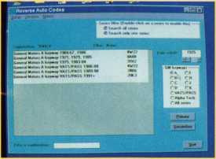

Photo 7

manageable list in photo 7.

Other code programs have an included feature something like RAC, and if you have no or very limited need or use for that feature of your program, you probably wouldn’t be interested in RAC. If you use that feature a lot, though, the generally greater efficiency and speed of RAC might justify you buying it, even if you still keep and use your code program for looking up code numbers. The data is stored differently in RAC, and is optimized for looking up the cut combinations rather than the code numbers (as is more common for standard code programs). Also, RAC doesn’t require you to choose the code series first before searching for the cut combination. When testing it against other code programs,

RAC often listed a dozen or more different individual codes in a second or two, while some of the code programs took much longer. Even after selecting the correct code series to search, it sometimes took 20 to 30 seconds to find the one code number, and that was after spending the additional minute or two navigating through the program to find and select the correct code series.

Fill the Combination (FILL)

When fitting keys for cars, these days,

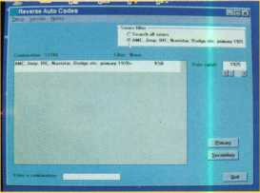

Photo 5

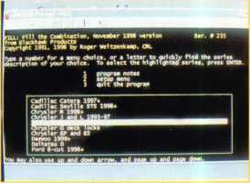

Photo 8

you will often find that no one lock on the car will have all the tumbler positions required for making a complete key. Although a key has a certain number of cuts, individual car locks will not have tumblers in all cut positions, and different locks will have different tumbler positions missing. You will generally need more than one lock to fit a complete key, or using one lock you may need to progres­sion the missing cut positions on a lock still remaining on the car. FILL is a program that allows you to search a code series when you only know part of the tumbler information, and create a computerized custom progression chart for the locks on which you are working. FILL is a DOS based program and will work on older DOS based IBM compati­bles and newer Windows machines (when switched to DOS mode).

Photo 8 shows the main screen. It has been scrolled down slightly, highlighting the code series Chrysler G 1989-1992.

The next screen, in photo 9, shows some key cutting information toward the top, and a place to input the known parts of the key combination toward the bottom of the screen. The Chrysler G series codes are the original seven-cut codes for Chrysler. Although the key had seven cuts, the door locks had tumblers in only the first five

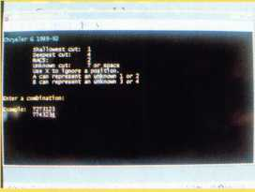

Photo 9

positions and the trunk locks had tumblers in only the last five positions. As a test sample, I used the code number G1250 that has a cut combination: 1243234. Simulating information from a trunk lock, the combination shown on the bottom of the screen is: ??43234, with the first two cut/tumbler positions missing.

The next screen, in photo 10, shows only eight different possible combinations for the two missing first digits. They are as follows: 1243234, 1343234, 2243234, 2443234,3243234, 3443234, 4343234 and 4443234. By pressing the letter “P”, a custom progression chart will be generated for those specific cut combina­tions. Photo 11 shows the progression.

The progression order for the first key is: 1243234,1343234,2443234, 3443234, 4443234. The second key is: 2243234, 3243234, 4343234.

As seen by my sample code, the progression chart would have generated a working key on the first try. If I had simulated information from a door lock instead, I would have input the combina­tion: 12432??, with the result in photo 12. The available possible combinations with the previously identified first five digits, and last two cuts possible in the G series codes turned out to be four. They are as follows: 1243213, 1243223,

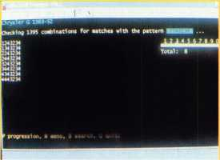

Photo 10

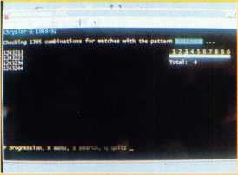

Photo 12

1243234, 1243244. When I selected a progression, it came out in the same order, using only one key. Using this progres­sion, I would have come upon the correct key combination on the third try.

FILL can generate custom progression charts for many different types of auto locks, but practicality depends on how many tumbler positions are missing and the resulting progression chart. With enough blank spots, you could conceiv­ably have a progression chart with a bitting list in the hundreds. You can use an “X” to ignore a position if certain cut positions are not needed, which will reduce the number of key combinations.

It will also allow you to use the letters “A” and “B” to simulate tryout key depths for 1 * and 3 *, etc... You can use “T” for depths 2 or 3 on Alpha Tech ignitions, and “F” for 4 or 5 on Alpha Tech and Ford 10-cut.

For more information about these or other locksmith computer programs, contact: Blackhawk Products, 25913 Road T.5, Dolores, CO 81323. Phone: (970) 882-7191. FAX: (970) 882-7228. blkhawk @ CompuServe. com Get Your Private, Free Email at http:!Iwww. hotmail. com

Photo 11

March 1999

27

Keynotes

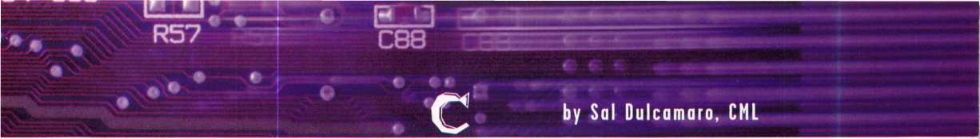

**MAGAZINE REFERENCE**

O

fronData Logic

It’s happened to many of us. A customer will bring in a lock, or call you and describe the lock that he needs serviced. It just so happens that you are vaguely familiar with the lock and haven’t had any hands-on experience with it. You want to take the job, but a little voice in your head tells you that there was an article in one of the locksmith magazines recently, and it said to be careful about something when working on that lock. Something tells you that messing up this lock would take a big bite out of your pocket book. You make up an excuse, and ask the customer if you can call him back shortly.

You run back to your library of locksmith magazines and start leafing through the various issues to find that article. It seems rather recent. It couldn’t be more than four months ago; probably three months ago. You find a two month old magazine still unopened in its poly bag and remember that you’ve been reading the magazines maybe a month or two after they arrive. Now, you think it could have been six or seven months ago. You look at your watch and discover that nearly thirty minutes have already passed. Feverishly, you start flipping through the pages trying to find that article. After an hour you give up. The magazine issue with the article is obviously in some black hole surrounded by anti-matter. You call back the customer and hope he hasn’t already called someone else. You’re having second thoughts, but when the customer

still wants you to look at the lock, you proceed full speed ahead.

Arriving at the job, you tell yourself that it can’t be that bad. Everything appears to go smoothly until a couple of odd-sized springs pop out of the lock. You search the floor and find nothing. You can’t remember if the article said the parts were easily or impossible to replace. As you buy your customer a new lock, you wish you knew where to find the article.

If only you had Magazine Cross Reference from Data Logic, you could have looked up the article and found the information that you needed. Magazine Cross Reference is a database program. It lists all the different articles found in the various locksmith magazines by publication name, month, year and page in the magazine. Photo 1 shows the opening screen. The layout is very much like any database. At the top left are arrows for selecting records. You can sort them one at a time, if you like, until you see something interesting.

You can select by using the letters of the alphabet at the top of the screen. In photo 2, the letter “U” has been selected, and it jumps down to “U-Change Locks.” You can then scroll to an exact place and select the record. A third way to find something is to use the magnifying glass icon at the top of the screen to do a specific search. Photo 3 shows the search set to look for Miwa. The results of the search show all the Miwa articles listed in photo 4.

This is a very handy program. Even though most of the magazines have an annual index, it is a major chore to track down all the index issues for each year and try to find what you’re looking for. The search is fast and easy. I recently used it to find some auto lock information for a fellow locksmith.

Data Logic has an Internet site and an online version of the Magazine Cross Reference program included with others. The online service is on a subscription basis requiring a user name and password. Photo 5 shows the Internet page. A list of programs is shown along with the online version of Magazine Cross Reference. Magazine Cross Reference has been selected in photo 6. It is somewhat similar to the opening screen of the program on computer diskette. You can choose by letter or select a specific subject. After selecting the letter “E,” the search results in the computer screen found in photo 7.

The online demo programs (available at <http://www.dtlgc.com/isrtst/>) are not full featured. They give you a general feel for the programs, but don’t allow you to access much of the total program. Subscribing to the service will keep you constantly updated. For more information, contact:

Data Logic

1820 Reliance Parkway, Suite #500 Bedford, TX 76021 Phone: (817) 267-8022 FAX: (817) 571-1991

e-mail: [dtlgc@flash.net](mailto:dtlgc@flash.net)

-.• • • • f m

♦* #

**3ELDR1I2**

64 C85

Ed

**■**

**28 I**

*m*

***Keynotes***

**-i#—**

R57

**“If only you hod Magazine Cross Reference from  
Data Logic, you could have looked up the article and**

**found the information that you needed.”**

p 11

m

C88

**March 1999**

**up r**

^ SAFE 6 VAULT TECH SEP U

-are there too many trade shows?** security REPORTER FEB n

"CWMETBWE" AURMS & PHYSICAL ffECURfTY KEYNOTES OCT *

"DO NOT DUPLICATE" CUT OB NOT TO CUT REED REPORTER SEP 5

-HOW DOES YOCRLOOCSHOP ADD UP" NATIONAL LOCKSMTIB DEC 12*

“HOWHONEST ARE YOC* KEYNOTES NOV 9

“HOWTO 8CRGIAR PROOF YOUR HOME" KEYNOTES NOV 9

“KEYS,CARS 6 SCAMS*TRYOUT KEYS.VIEWPOINT NATIONAL LOCKSMITH MAR 9

"LOCKSMTTHING: TRADE OR HOBBY" C0VN LAWS SAFE A VAULT TECR OCT f

NATIONAL LOCKSMFFH MAR 14

LOCKSMrrH LEDGER AUG 111

SECURITY REPORTER FEB 41

safe a vault tech. tan 2*

SAFE & VAULT TECH OCT l)

KEYNOTES OCT 24

LOCKSMITH LEDGER MAY U

NATIONAL LOCKSUffTH DEC I5t

RHED REPORTER NOV it)

: SECURITY REPORTER MAR 15

i CHANGE LOCK DISASSEMBLY/SERVICI l CHANCE LOCKCOMPANY INFO 'CHANCE PKTQMG TECHNIQUES IL BURGLARY SAFE CLASSIFICATIONS

t VAULT TECa

SAFE & VAULT TECH

“PADLOCK TORTURE TESTING”

“PRO LOCK" MOTION UU DISABLE "RESIDENnAL SAFE HAVENS"

-SAFE OPENING** BY DAVE MCOMIE BOOK INFO

"Safety and the security industry- osha

US. SECURITY SQUARE DOOR OPEN / LAGARD US, SECCRTTY1 HINGED SQUARE DOOR SAFE US. SECURITY: r* MONEY CHEST SAFE US. SECURITY ITL15 MONEY SAFE US SECTRITY-4 PLATE SAFE US. SECURITY-4 PLATE STEEL SAFE US.SECURITY m 199 SAFE WEAGAKI) HM |l?qgDA HRE SATE OPENING JAPANESE

' ABOUT CRIME"

SAIE£ VAULT TECR

Magazine Cro XStjM

Magazine Cro.,

Magazine | Mih jPegtj Year

Q-V[V-lMi T^lviUNcHe

jU CHANGE LOCK-COMPANY INFO ■II-CHANGE PICKING TECHNIQUES IlLU BURGLARY SATE CLASSffICATIONS jl'.LPOUKTKHINTO jus. LOCK BIG DOTY DEADBOLT REVIEW jus. LOCK BIG DOTY DEADBOLT REVIEW jjc liS. LOCK RXDEALHtKEVWAV REVIEW | US. SECURITY FLOOR SATE B RATE 1

| US SECURITY SATE INTO I US. SECURITY SATE OPENING

. SECURITY SQUARE DOOR OPEN LACARI) NATIONAL LOCKSMITH

■V n

X instant Access

Magazine Cro.

Internet Security Reference

Search Mode:) Some of the Words

j:;TiInternet Secu

*j_3 V XInstant Access i[[p-internet Secu ityi&jf-i

Internet Security Reference

'IOCS5MIIH LEDGE*

[keynotes

jCStartj ^ *1 V X install! A-. ;ecs ||gnInternet Sccu..

iMMagazint

|  |  |  |  |
| --- | --- | --- | --- |
| ■ J K loc4«^hep Z/W, ■: * -■■■■■-  ■' 3 tr**** ; j lookup Jj NowJrCaoi  1 Internet Security Reference  | [li^licioiwmi!iw j.  1 [Secured Forum-**-; | | 2S2S] |  |
| I «P.gQ?me..Cw5s.R e)e age $ | Best 1C Utilities-**' |  |  |
| 1 Keyblqnk Cross Kelt “ |  |  |  |
| I Se.cu_iity_McinyJqcty.rer5 Database |  |  |  |
| I Space 4 Depth Database  I Master Padlock Codes - Mrsc | Master Key Piys • Web Version | |  |

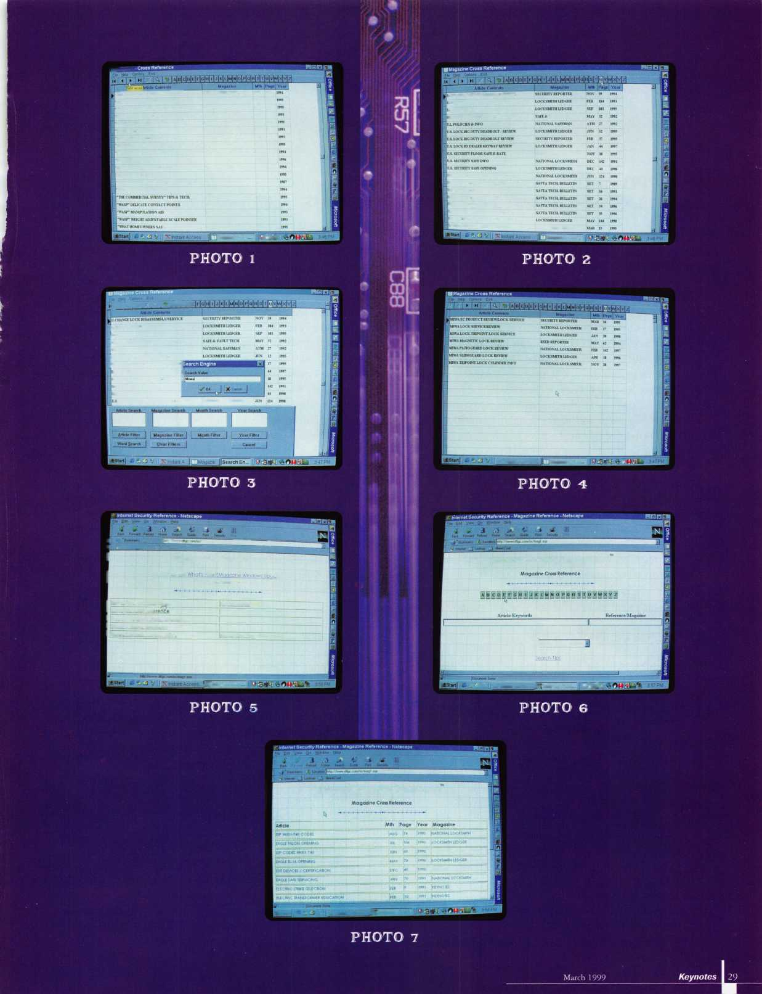

by Tim McMullen

BEING PRO-ACTIVE:

ALOA HELPS THREE STATES STEP UP TO THE PLATE

The legislative year began with a slow start (only a few bills introduced in the first four weeks), but then got busy around the middle of February (see Legislative Update below). ALOA is playing a key role in three states, which are approaching this session by being pro-active in helping locksmiths succeed.

Recently in Arizona, House Bill 2493 was introduced which was a big breakthrough for locksmiths in that state. The bill defines what constitutes a “lock” and a “locksmith” under the chapter in the Arizona Code dealing with trade practices (Title 44, Chapter 9). This means that what locksmiths do will be recognized by the state as a trade (something we already knew!). The advantage of this is that if there is anything that would affect locksmithing as a trade (i.e. change in building codes), locksmiths would be notified. Also, if legislation is introduced that might affect locksmithing, we would already be recognized and defined under the code (i.e., a future alarm bill).

The second thing the bill does is codify ALOA’s Positive ID Policy. This requires locksmiths to keep a record of their transactions, something ALOA already supports, and which actually protects the locksmith from liability. This bill is a culmination of work started over two years ago by the Grand Canyon chapter of ALOA, the Professional Association of Locksmiths of Arizona (PAL) and the Southern Arizona Locksmith Association.

What this bill doesn’t do, however, is protect the trade from others who do lock picking work but are not locksmiths (i.e. police officers,

LEGISLATIVE UPDATES

ARIZONA H2493

AUTHOR: Gerard, et al

INTRODUCED: 01/12/1999

SUMMARY: Relates to locksmiths; relates to work orders;

relates to information retention.

STATUS: 01/12/1999 INTRODUCED.

02/03/1999 From Senate Committee on Commerce: Do pass.

CONNECTICUT S112

AUTHOR:

INTRODUCED:

SUMMARY:

STATUS:

Gafifey

01/11/1999

Requires the licensing of locksmiths.  
01/11/1999 INTRODUCED.

01/11/1999 To JOINT Committee on  
GENERAL LAW.

ILLINOIS H620

AUTHOR: Capparelli, et al

INTRODUCED: 02/04/1999

02/10/1999 Sent to Committee on Executive.

tow truck operators, hardware stores). It also doesn’t protect locksmiths from other people owning lockpick tools. It is a start and one that puts locksmiths on the books! To find out how to contact your state representative to support this bill, contact me at 800-532-2562.

In Illinois, a pair of bills (H620 and H621), were introduced as an attempt to clarify language in the current law. Since January of 1998, ALOA has received numerous complaints from our Illinois members regarding hardware stores, local police, and tow-truck companies violating the Private Detective, Private Alarm, Private Security, and Locksmith Act. We’ve argued with the state that to license locksmiths while allowing other groups to do the same work defeats the intended purpose of the law. To allow other professions to do the same work without proof of competency, we’ve said, puts the consumer at risk. These bills are designed to correct those problems. To find out how to contact your state representative to support this bill, again, contact me.

Finally, in Connecticut, a bill was introduced that allows the legis­lature to write a locksmith licensing law! The locksmiths in the Nutmeg state have taken it upon themselves to draft legislation that would benefit all.

ALOA is committed to all members who face legislation in their state, and look forward to working with Chapters and state and regional locksmith associations to ensure another successful year!

SUMMARY:

STATUS:

ILLINOIS H621

AUTHOR:

INTRODUCED:

SUMMARY:

STATUS:

Amends the Private Detective, Private Alarm,  
Private Security, and Locksmith Act of 1993;  
deletes the phrase “at premises, vehicles, safes,  
vaults, safe deposit boxes, or automatic teller  
machines” from the definition of “the practice of  
locksmithing”; effective immediately.  
02/04/1999 INTRODUCED.

02/10/1999 Sent to Committee on Executive.

Capparelli, et al

02/04/1999

Amends Private Detective, Private Alarm,  
Private Security, and Locksmith Act of 1993;  
provides that police, fire or other municipal  
employees may open a lock in a life-threatening  
situation or when the location of a vehicle creates  
a danger to the public; effective immediately.

02/04/1999 INTRODUCED.

Keynotes

March 1999

ILLINOIS S212

AUTHOR:

INTRODUCED:

SUMMARY:

STATUS:

INDIANA S53

AUTHOR:

INTRODUCED:

SUMMARY:

STATUS:

Burzynski

02/03/1999

Allows the Director to suspend a license without  
a hearing if continuation in practice would  
constitute an imminent danger to the public.  
02/03/1999 INTRODUCED.

02/03/1999 To SENATE Committee on RULES.

Meeks

01/06/1999

Requires a person who operates a business that  
installs, repairs, or services an alarm system to be  
licensed; establishes an alarm system board;  
establishes licensure and registration require-  
ments for the regulation of alarm system contrac-  
tors and their employees; requires employees of  
an alarm system contractor to be registered and  
have identification cards; staggers the terms of  
the initial appointments to the board.  
01/06/1999 INTRODUCED.

01/06/1999 To SENATE Committee on  
PUBLIC POLICY.

IOWA H203

AUTHOR: Bradley, et al

INTRODUCED: 02/03/1999

SUMMARY: Relates to the licensure or regulation of alarm

system, bail enforcement, private investigation or private security businesses; provides a penalty. Definition of an alarm system includes electronic access control.

STATUS: 02/03/1999 INTRODUCED.

02/03/1999 To HOUSE Committee on STATE GOVERNMENT.

MISSISSIPPI S2649

AUTHOR: White

INTRODUCED: 01/13/1999

SUMMARY: Provides for the licensure and regulation of

burglar or intrusion alarm system installers; defines certain terms used in the act; creates the Electronic Security Board of Licensure; provides for its powers and duties; provides for an annual license fee; excludes certain persons from the application of the act; provides for civil and criminal penalties for violations of the act.

STATUS: 02/02/1999 Died in committee.

NEVADA All 5

AUTHOR: Committee on Commerce and Labor

INTRODUCED: 02/03/1999

SUMMARY: Extends date of expiration of permit to operate as

locksmith or safe mechanic.

STATUS: 02/04/1999 To ASSEMBLY Committee on

COMMERCE AND LABOR.

NEW YORK A515

AUTHOR: Kaufman,et al

INTRODUCED: 01/06/1999

SUMMARY: Provides that class A multiple dwellings have

eight or more apartments erected or converted prior to 1968, must have automatic self-closing and self-locking doors at every entrance from the street, roof, passageway, courtyard, cellar or other entrance; excludes main entrance halls and lobbies if equipped with automatic self-locking doors.

STATUS: 01/06/1999 INTRODUCED.

01/06/1999 To ASSEMBLY Committee on

HOUSING.

NEW YORK A718

AUTHOR: Hill, et al

INTRODUCED: 01/06/1999

SUMMARY: Permits a state income tax deduction for home

security devices, including but not limited to exterior lighting, installed by the owner occupant of a one, two or three family home for an amount not to exceed $500.

STATUS: 01/06/1999 INTRODUCED.

NEW YORK A3889

AUTHOR: D’Andrea, et al

INTRODUCED: 02/04/1999

SUMMARY: Provides that a taxpayer 65 years of age or over

shall be allowed a credit against personal income tax for the purchase and installation of a security device in his principal residence located within the state; provides that such credit is limited to 50% of the expenditure not to exceed a maximum of $400.

STATUS: 02/04/1999 INTRODUCED.

02/04/1999 To ASSEMBLY Committee on WAYS AND MEANS.

March 1999

Keynotes

31

The importance of presenting a profes­sional appearance as a Locksmith can not be overstated. When I first started my business, I wanted to provide a service to my community that would be needed and remembered by my customers. In order to be recognized and remembered by my customers, I knew that my business card had to be extremely unique. It was important to project the right image from the first day when I started my business. That image was my business card.

When I arrived at my first service call,

I knew that the customer would see my shop van, which had to display a profes­sional image. I introduced myself, by presenting my Locksmith Identification Card (State Affiliation Locksmith Associ­ation Card) and my business card.

The importance of presenting a profes­sional looking business card to my customer was critical to my success as a Locksmith. The standard business card is only two-inches by three and half inches. The size of this card is considered small, but it is the most important piece of information that your customer will have to remember you by when you leave his home or office.

Many large corporations and small  
32 | KeynotesMarch 1999

business companies will have their repre­sentatives present a business card to their customers. This is a form of advertising for the business, and most importantly, it represents the individual who will provide a service. Whether it is designed to fit in a Rolodex card file or to be placed in a drawer or an individual pocket, this card represents you and your company.

In designing my business card, I first collected a number of business cards from my friends. I also attended several locksmith trade shows and always asked those locksmiths attending for their business card. I also reviewed a number of books on the subject concerning the design and layout of a business card. I would recommend two books, Creating Logos and Letterheads by Jennifer Place (North Light Books). It is an excellent and simple book to help a person design a Business card. Another book would be, The Best Business Card Design by Stephen Pearson (Rockport Publishers).

After accumulating several dozen business cards, I began to separate the ones that stood out from the rest and discarded those that did not seem to match my image. I chose the design, lettering and color for my business card based upon the following items.

Use A Professional To Help You Design The Card

There are a number of graphic arts companies in your neighborhood that can help you with the design and lay out of this card. I was fortunate to have a son-in- law (Eric Miller in Dallas, Texas) who is a graphics design engineer. He helped me with the layout of the card. Although I could have done this process myself, it’s always better to have someone review the design and layout of any business card as a disinterested party. This person will not only tell you what he thinks, but he will tell you if the card makes sense, and most importantly if it gets the message across.

The Logo

The most important item that I wanted the customer to remember when I finished the job is the company’s logo and name as well as the locksmith who did the work. I chose a local landmark (a lighthouse) as the logo to place on my card. Living on Nantucket Island, 30 miles at sea, off the coast of Massachu­setts, the island has three distinctive lighthouses. It was a great choice because I can’t tell you how many calls I receive from individuals and businesses that ask

me, “Are you the Locksmith with the Light House on his van?.” It’s not necessary to have a logo on your business card but it is a distinctive trait for your card. In choosing a logo, be careful that it is not already protected under copyright laws. The next item on my list was to choose a business name.

The Business Name

When choosing a name for my company, I knew it had to be one that could be remembered and recognized immediately by the community where I lived. I live on an “Island” and I am a “Locksmith”, therefore the name of “Island Locksmith” seemed natural. To insure someone else did not already use the name in my local area or state, I registered the name with the state­licensing branch responsible for this activity. The cost was minimum, and it guaranteed me that no one else in the state could use this business name.

Every locksmith in what ever state you live in should register the business name, it makes sense, and it protects your good name. Now to choose the right business card.

The Business Card

Any business card you receive today has at least three items on it: 1) the name of the company; 2) The name of the person that represents the company; 3) the telephone number of the company.

We have already talked about a logo and the business name, so now, lets discuss the persons name. This is the most important item anyone can put on any business card. Your name will be remembered, because it represents the person that performed a service for the individual or company. When placing your name on the business card, ensure it is the name you want the individual or business to remember. The use of nicknames or trade names is acceptable if that is how you want to be called and/or remembered. I would recommend using

**cqwsu**

- **Made**

\CeVs

Locks ReP;

Opening*«

your full and legal name. It is the first  
thing your parents gave to you, so be  
proud of it. After all its something you  
will pass on to your children.

After listing these three basic items, it  
is important to also to list the address of  
your company, and at least one main

business phone (area code included)  
where they can reach you at 24 hours a  
day. With the introduction of the fax  
machine, E-mail address, pager, cell

phone and answering machine, not  
to mention the 24 hour emergency  
telephone number, your business  
card can become full of information.

Leave the backside of your business card  
blank for people to write something  
down. How many times have you used a  
matchbook for that purpose?

I would recommend only two  
telephone numbers. The first number is  
my main telephone business number,  
(answered by my answering machine  
when I am not in my shop) and my

emergency number (cellular  
phone). More then two telephone  
numbers listed on any business  
card will only confuse the  
customer and clutter up your

card. With the introduction of  
the E-mail address, it is

becoming more common  
now to see this item on a  
business card.

Thus far, weve covered  
logos, business names and

effective use of contact numbers and

addresses. Next month, I’ll discuss other

elements to take into consideration  
when designing your business card  
including the size or sizes of lettering,  
color of ink and paper.

Emergency

LESLIE J. TAYLOR  
20 **Santult** Pond Road  
Mashpee, MA 02649-2420  
508**-**477-6270

ISLAND LOCKSMH

BONDED • 1 ~

#8777

PHYSICAL SECURITY CONSUl ' OCKSMITH SERVICE

61 SLtt tfWNSON.**-

^oL^NrpLoCK

s£cui

*\*?HOUr*

'%ITy

*c£NTi*

Buqu **San Soucie**

**Locksmith**

*for over 20 years*

**•O.eal0^Sd took sets**

**ir**

Sale Co^

**28N»on«**

**Turoers^a 5**

**\*163**

**fa*1**

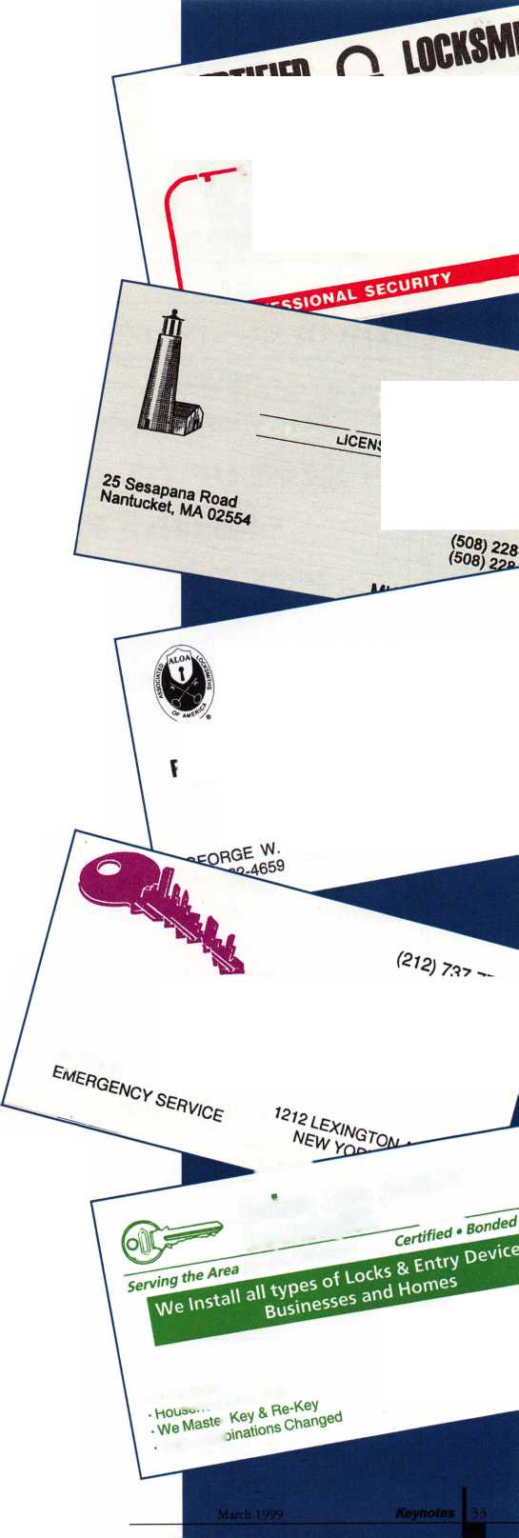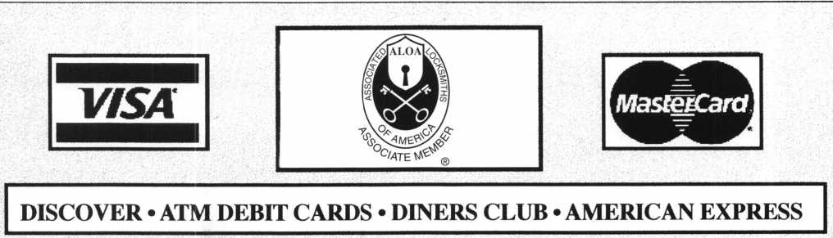

You pay ONLY 25 C flat per transaction  
by processing

through our Check Card/Debit System!

Attention Merchants Currently Accepting Credit Cards:

• SAVE UP TO 35% OR MORE in Credit Card Fees!  
• Receive Pin Pad ABSOLUTELY FREEH  
FREE CONVERSION PROGRAM FOR ALOA MEMBERS

*HOW IT WORKS*

By using our FREE Pin Pad, which simply  
plugs into the back of your terminal,  
you bypass

the Visa/MasterCard network &  
Eliminate Your Current Percentage Rate

on ALL Visa/MasterCard “Check Cards”  
(normally 1/3 of the credit cards processed).

The operation of your terminal and your wired funds will remain unchanged.

Accept virtually every debit card used in the U.S. with $10 monthly access fee.

Drop your current credit card rate to 1.59% or lower.

Universal Payment Processing provides 24 hour live customer service.

FOR YOUR QUICK - SIMPLE - HASSLE FREE  
CONVERSION

Fax Express Mini Form Below To 1-800-439-7773

i ' — — — — 1

I Company Name

J Contact Name

| Address

| City

I

| Phone.

Terminal Type

State Zip

Best Time

Printer

/r

Marketing Office ***1****-****800****-****836-4295***

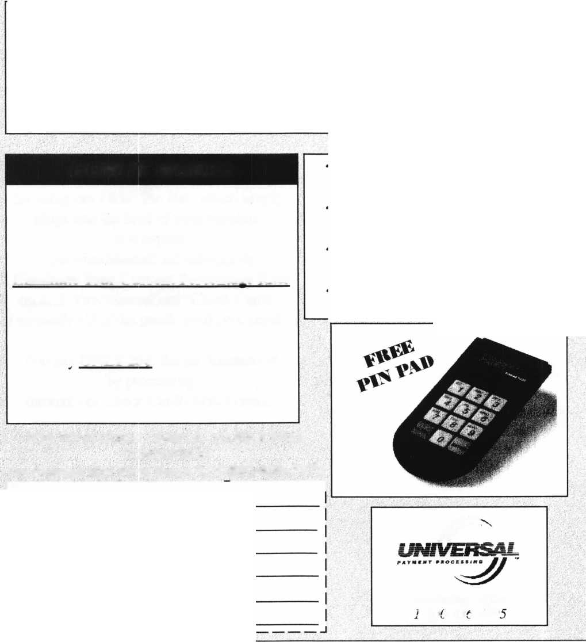

mnvci

SO, YOU THINK YOU WANT TO BE

**mall Town Locksm**

**By C.D. Lipscomb, CML, CPS**

In a small town, there is usually the same need for things that are commonly found in the big city. Sometimes, however, there is often not enough volume of business to support a good locksmith.

The rule of thumb is, in a rural area, (and this includes a small town) it takes a population base or entire service area of40,000 people to support one locksmith shop. In an urban area, it takes much less people (about 15,000) to support a locksmith shop.

In a rural area, people tend to be more self- reliant and mechanical in nature. This is usually out of necessity as they tend to install their own locks and find ways to compensate for the lack of an available locksmith.

In these rural circumstances, carpenters install door locks, lumber yards and hardware stores pin the locks, mechanics install new automotive locks instead of making keys, and tow truck drivers and police tend to open the cars. This is all done out of necessity because of the lack of an available professional locksmith. Only safe work, in the most extreme cases, is left to locksmiths, who often have to travel a considerable distance to get to the job.

It is difficult to penetrate such a market successfully because of these established trends. Usually the people who do these lock related jobs in a rural area tend to charge lower prices than that of a locksmith. Usually, however, their work won’t compare favorably to that of a professional locksmith. The public tends to become accustomed to the low prices and lesser quality work, which makes it really hard for a professional to make a living while trying to establish a business in such a place.

There is a large investment in tools and knowledge required. The return on that investment is not always enough to make it worth it. Add to that, the burden of having to learn and keep up with the trade while doing well enough to pay the bills. It takes about 5 years to establish a customer base and get onto

a paying basis in any market, and more so in a small market. Where there has not been a local locksmith established, the community has to be educated to even use a locksmith. That takes a long time and a lot of effort. Many technically good locksmiths have gone broke trying to do this.

In a small town, you rarely get exposed to enough challenging things to really learn to be good, or stay up with current technology. There is usually no one to mentor or teach you there. So, to become good, you have to try harder , study longer, and travel further. I have personally found that a self-taught, on-the-job, learn-as-you-go education is the most lengthy, painful and expensive thing that you can imagine. In this case, the only good teacher is hard knocks, and hard knocks often hurt.

If you are just beginning, and you are not already self-employed with a trade that will support you while you learn and are VERY mechanically inclined, I would look for something else. It is just too hard otherwise.

It used to be that a person could retire, quit or get fired from another job, make a career change at mid-life, go into locksmithing and be reasonably successful. With the avalanche of new technology, that is rapidly changing. There is just simply too much to learn to do it even in a few years. Like many other fields, lock- smithing is starting to center around high technology, and electronics. If you don’t have what it takes to learn new stuff, then lock- smithing, particularly in a small town, is not for you. That becomes much harder as one grows older. I know. I am 51, and would not try to get where I am now, starting at my age, knowing what I know now about how hard it is to do.

I have been in locksmithing and the physical security field for 24 years. I’ve been doing it full time for the last 10.1 also live in a small town (24,000). I am a Certified Master Locksmith (ALOA certified) and a Certified Professional

Safe Technician (SAVTA certified). I was (and still am for that matter) a construction engineer, a carpenter and a self-employed contractor before becoming a locksmith. My customer base was pretty well established when I made the conversion, which was fairly gradual.

In my search of education, knowledge and competence, I have become an active member of many locksmith associations (ALOA, SAVTA, Texas Locksmith Association, Oklahoma Master Locksmith Association to name a few), and remain a member of them today.

The above list represents a lot of dues, and time expended to attend the meetings, classes, conventions and read all the correspondence of all these associations. I do try to attend as many meetings as is possible. All of the groups have been important to me in my ongoing development as a locksmith/safetech. I have felt that it was necessary to belong to each of these organizations in order to gain the necessary exposure to other, more knowledgeable locksmiths and safetechs, and their experiences. To me, the classes are necessary to gather the knowledge and information crucial for me to be able to perform my work. The requirements of excellence, and competency are the same whether in a small town, or large city.

The point is, this is what I have found you have to do when you don’t have a mentor, or person to apprentice under, as is often the case in a small town. Becoming a locksmith is an expensive, time consuming and hard experience. Such a life is also extremely satisfying. There is also the immense satisfac­tion of being among peers who are among the best people in the world.

I understand that I have painted a pretty tough picture of this business but that is what it is, and the way things are. I would do you no favor to make it look easier than it is. Good luck on whatever you do.

March 1999

Keynotes **111**

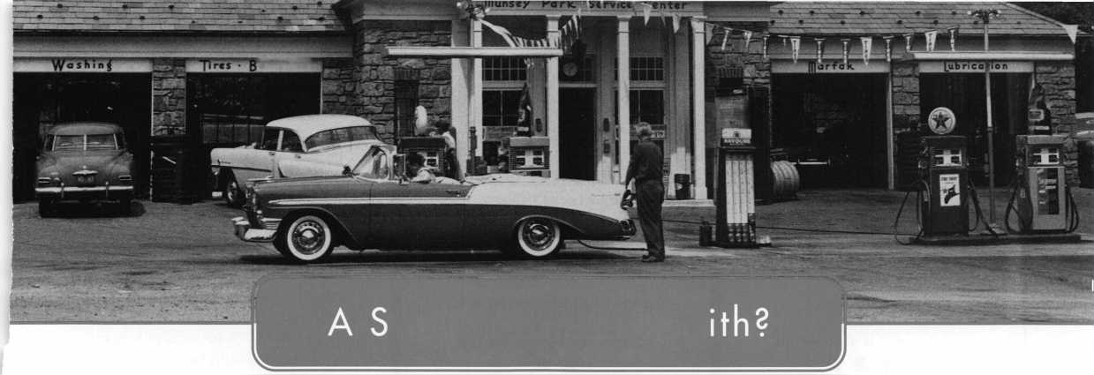

Associate

|  |  |
| --- | --- |
| Members | 1 O' |
| Manufacturers | Arrow Lock Company  10300 Foster Avenue  Brooklyn, NY 11236 (718) 257-4700; FAX (718) 649-9097  • •M |
| A & B Safe Corp.  171 S. Delsea Dr.  Glassboro, NJ 08028 (800) 253-1267; FAX C609) 863-1208  • • • • | Auto Security Products (A. S. P.)  P.0. Box 10  Redmond, WA 98073-0010 (425) 556-1900; FAX (425) 558-1205  • • |
| ASSA Inc.  10300 Foster Ave.  Brooklyn, NY 11236 (800) 235-7482; FAX (718) 257-2772  • | BWD Automotive  900 Ravenwood Dr.  Selma, AL 36701  (334) 874-9001; FAX (334) 874-6011  0 • |
| Abus Lock Company  3555 Holly Lane North  Plymouth, MN 55447-0507 (800) 352-2287; FAX (612) 509-9939  • | Chicago Lock Company  10100 88th Ave.  Pleasant Prairie, Wl 53158-0069 (800) 445-3204; FAX (414) 947-7178  e |
| Adams Rite Manufacturing Co.  P.0. Box 1301  LaPuente.CA 91749-1301 (562) 699-0511; FAX (562) 699-5094  MM | Corbin Russwin Architectural Hardware  P.0. Box 25288  Charlotte, NC 28229 (800) 543-3658; FAX (800) 447-6714  MM |
| Adesco Safe Manufacturing Co.  web: [www.adesco.com](http://www.adesco.com) email: [sales@adesco.com](mailto:sales@adesco.com) (800) 821-6803; FAX (562) 408-6427  • | Curtis Industries  6140 Parkland Blvd, Ste. 300  Mayfield Heights, OH 44124-4103 (800) 555-5397  0 • |
| Adrian Steel Company  web: [www.adesco.com](http://www.adesco.com) email: [sales@adesco.com](mailto:sales@adesco.com) (800) 677-2726; FAX (517) 265-5834  • | DETEX  302 Detex Dr.  New Braunfels, TX 78130 (800) 729-3839; FAX (830) 620-6711  • • • • |
| Alarm Lock Systems, Inc.  345 Bayview Ave.  Amityville, NY 11701 (800) ALA-LOCK; (516) 789-3383  • | Don-Jo Manufacturing, Inc.  P.0. Box 929  Sterling, MA 01564 (508)422-3377; FAX (508) 422-3467  0 • |
| Aiphone Intercom Systems  1700-130th Avenue, NE  Bellevue, WA 98005 (425) 455-0510; FAX (425) 455-0071  • • • | Door Controls International  2362 Bishop Circle East  Dexter, Ml 48130  (800)742-3634; FAX (800) 742-0410  0 0 0 0 |
| American Lock Co.  3400 West Exchange Road  Crete, IL 60417-2099 (708) 534-2000; FAX (708) 534-0531  0 • | ESP Lock Products, Inc.  375 Harvard Street  Leominster, MA 01453 (978) 537-6121; FAX (978) 534-9109  0 0 |
| American Security Products (AMSEC)  11925 Pacific Ave.  Fontana, CA 92337-6963 (800) 423-1881; FAX (909)685-9685  0 • | Folger Adam Security, Inc.  16300 W. 103rd Street  Lemont, IL 60439  (630) 739-3900; FAX (630) 739-6138  0 0 |
|  |  |

Associate members of the Associated Locksmiths of America (ALOA) manufacture or distribute materials or equipment, or provide services, for the security industry. Many have donated money, services and equipment to ALOA in addition to their annual dues. Their support of ALOA projects enhances overall membership benefits and we encourage our members to patronize these firms. If you know of a potential candidate for associate membership, please contact the ALOA Membership staff at (800) 532-ALOA. Associate member dues are $500 per year and entide the payor to use the ALOA logo, and selected discounts on ALOA products and services.

Legend

9 Alarms: Personal, vehicle, electronic, five, burglar, and exit

**9** Automotive: Lockout equipment, key chains/rings

9 Builders Hardware: Door closers, furniture/decorative hardware, viewers, emergency exit devices

Books, reference guides, publications, computer software

9 CCTV/Photo Imaging: Cameras, monitors, photo ID equipment, cables

access control and readers, surveil­lance, electric/magnetic locks and strikes, keypads

9 Lock Devices: Auto locks, cylinders, emergency exit/entrance control, locks (various types), strikes

9 Tools & Supplies: Key blanks, cutters, picks, rings/hooks, custom van/truck supplies



***Keynotes***

March 1999

|  |  |  |
| --- | --- | --- |
| Fort Lock Corp.  3000 N. River Rd.  River Grove, IL 60171 (7083 456-1100; FAX (7083 456-9476 | Lori Lock  P.O. Box 1040  Southington, CT 06489 (8603 621-3605; FAX (2033 621-5972 | STRATTEC Security Corp.  3333 W. Good Hope Rd.  Milwaukee, Wl 53209 (4143 247-3333; FAX (4143 247-3329 |
| •••••• | o • | 9 • • |
| Grobet File Co. of America  750 Washington Ave.  Carlstadt, NJ 07072 (8003 962-7242; FAX (8003 243-2432 | Lucky Line Products  7890 Dunbrook Rd.  San Diego, CA 92126 (6193 549-6699; FAX (6193 549-0949 | Sargent & Greenleaf, Inc.  P.O. Box 930  Nicholasville, KY 40340-0930 (6063 885-9411; FAX (6063 887-2057 |
| • | • | • • • • |
| H.E.S., Inc.  2040 W. Quail Ave.  Phoenix, A Z 85027 (6023 582-4626; FAX (6023 582-4641 | M.A.G. Engineering & Mfg. Inc.  15261 Transistor Lane  Huntington Beach, CA 92649 (7143 891-5100; FAX (7143 892-6845 | Schlage Lock Co.  1915 Jamboree Suite 165  Colorado Springs, CO 80920 (8003 847-1864; FAX (8003 452-0663 |
| • • • | Ml | • • |
| HPC, Inc.  3999 N. 25th Avenue  Schiller Park, IL 60176 (8473 671-6280; FAX (8473 671-6343 | MARKS USA  5300 New Horizons Blvd.  Amityville, NY 11701 (5163 225-5400; FAX (5163 225-6136 | Schwab Corporation  3000 Main St.  Lafayette, IN 47903-5088 (7653 447-9470; FAX (7653 447-8278 |
| • • • | 9 | • |
| llco Unican  400 Jeffreys Road  Rocky Mount, NC 27804 (9193 446-3321; FAX (9193 446-4702 | MUL-T-LOCK USA, Inc.  300-1 Route 17 South Suite A  Lodi, NJ 07644  (8003 562-3511; FAX (9733 778-4007 | Securitron Magnalock Corp.  550 Vista Blvd.  Sparks, NV 89434  (8003 624-5625; FAX (7023 355-5636 |
| ••••••• | • • • | • • |
| In Out Systems, Inc.  3650-B Matte Boulevard  Brassard, Quebec J4Y-2Z2, Canada (4503 444-5949; FAX (4503 444-4656 | Master Lock Company  2600 North 32nd Street  Milwaukee, Wl 53211 (4143 444-2800; FAX (4143 449-3114 | Security Door Controls  3580 Willow Lane  Westlake Village, CA 91361 (8053 494-0622; FAX (8003 959-4732 |
| • • | 9 9 | • |
| Intellikey  551 S. Apolo Boulevard, Suite 204  Melbourne, Florida 32901 (8003 226-0703; FAX (4073 724-0811 | Medeco Security Locks  P.O. Box 3075  Salem, VA 24153  (5403 380-5000; FAX (5403 380-5010 | Security Solutions  1640 W. Hwy. 152  Mustang, OK 73064 (4053 376-1600; FAX (4053 376-6870 |
|  | • • • | • • • |
| KABA High Security Locks  P.O. Box 490  Southington, CT 06489 (8603 621-3601; FAX (8603 621-9727 | Meilink Safe Company  111 Security Parkway  New Albany, IN 47150 (8003 634-5465; FAX (8003 896-6606 | Sentry Group  900 Linden Ave.  Rochester, NY 14625-2784 (7163 381-4900; FAX (7163 381-8559 |
| • | • | 9 |
| KEY-BAK; Div. of W. Coast Chain Mfg. Co.  1460 S. Balboa Ave.  Ontario, CA 91762 (9093 923-7800; FAX (9093 923-0024 | NKL Industries Ltd.  1111-13 Cavalier Blvd.  Chesapeake, VA 23323 (8003 528-9900; FAX (7573 485-0271 | Sully Tools Inc.  3515 Nodding Pine Ct.  Fairfax, VA 22033  (7033 689-3416; FAX (7033 787-0869 |
| • 911 | • • • • | • • • |
| Knaack Manufacturing Co.  420 E. Terra Cotta Ave.  Crystal Lake, IL 60014 (8003 456-7865; FAX (8153 459-9097 | National Cabinet Lock  200 Old Mill Road, P. 0. Box 200  Mauldin, SC 29662 (8643 297-6655; FAX (8643 297-9987 | TIB Canada Ltd.  2164 Oneida Crescent  Mississauga, Ontario, Canada L5CIV6 (9053 566-9198; FAX (9053 566-9697 |
| • | 9 | • •••• |
| LAB Security  700 Emmett St.  Bristol, CT 06010  (8003 243-8242; FAX (2033 583-7838 | Newman Tonks  805 N Buckman St  Shepardsville, KY 40165 (8003 826-5792; FAX (8003 777-8229 | Taymor Industries, Inc.  1586 Zephyr Ave.  Hayward, CA 94544 (8003 388-9887; FAX (8003 288-8133 |
| • | • • | • • |
| LCN Closers (Division of Ingersol)  121 W. Railroad Ave.  Princeton, IL 61356 (8153 875-3311; FAX (8153 875-3222 | ROFU International Corp.  2004-B 48th Ave.; Court E  Tacoma, WA 98424 (8003 255-7638; FAX (2533 922-1728 | Trine Products Corporation  1430 Ferris Place  Bronx, NY 10461  (7183 829-4796; FAX (7183 792-9127 |
| • | 9 9 9 | 9 9 9 |
| La Gard, Inc.  3330 Kashiwa Street  Torrance, CA 90505 (3103 325-5670; FAX (3103 325-5615 | Rutherford Controls Inc.  2697 International Pkwy, Bid 5 #100  Virginia Beach, VA 23452 (7573 427-1230; FAX (7573 427-9549 | Weiser Lock Company  6700 Weiser Lock Blvd.  Tucson, AZ 85746  (5023 741-6338; FAX (5203 741-6363 |
| • • • | • | • • |
|  |  |  |

Keynotes 137

March 1999

|  |  |  |
| --- | --- | --- |
| Yale Security Inc.  P.0. Box 25288  Charlotte, NC 28229-8010 (800) 438-1951; FAX (800) 338-0965  • • • • | Dire’s Lock & Key Co.  2201 Broadway  Denver, CO 80205  (303) 294-0176; FAX (303) 294-0198  ••••••••••• | Hardware Suppliers of America  P.O. Box 2208  Winterville, NC 28590 (800) 334-5625; FAX (800) 334-5635  • • |
| Zhongshan Hua Feng Lock Products  S Yongning Industrial Roaa Ziaolan Zhongshan Guangdong, China  86-760 227 82 63; FAX 86-270 227 80 63  • | Direct Security Supply, Inc.  36 Lincoln Street  Boston, MA 02135 (800) 252-5757; FAX (800) 452-8600  ••••••• | IDN, Inc.  1000 S. Main, Suite 280  Grapevine, TX 76051 (817)421-5470; FAX (817) 421-5468  •••••••••• |
| Distributors | Doyle Lock Supply  2211 W. River Road N.  Minneapolis, MN 55411 (800) 333-6953; FAX (612) 521-0166  ••••••••••• | Intermountain Lock & Supply Co  3106 South Main Street  Salt Lake City, Utah 84115 (800) 453-5386; FAX (801) 485-7205  •••••••••• |
| Accredited Lock Supply Co.  P.O. Box 1442  Secaucus, NJ 07096-1442 (800) 652-2835; FAX (201) 865-5031  ••••••• | Dugmore & Duncan Inc.  30 Pond Park Rd.  Hingham, MA 02043 (888) 384-6673; FAX (888) 329-3846  ••••••• | JLM Wholesale, Inc.  3095 Mullins Ct  Oxford, Ml 48371-1643 (800) 522-2940; FAX (800) 782-1160  • • • |
| Ace Lock & Security Supply Co.  565 Rahway Ave.  Union, NJ 07083-6631 (800) ACE-LOCK; (800) ACE-FAX4  •••••••• | E. L Reinhardt Co., Inc.  3250 Fanum Road  Vadnais Heights, MN 55110 (800) 328-1311; FAX (612) 481-0166  •••••• | Jo-Van Distributors Inc.  929 Warden Ave.  Scarborough, Ontario MIL 4C6 (416) 752-7249; FAX (416) 752-3845  ••••••••••• |
| Akron Hardware Consultants, Inc.  2579 South Arlington Road  Akron, OH 44319  (800) 321-9602; FAX (800) 328-6070  see | Ewert Wholesale Hardware  4709 W 120th St  Alsip II 60658  (800) 451-0200; FAX (708) 597-0881  • • • • • | Lockmasters, Inc.  5085 Danville Road  Nicholasville KY, 40356 (800) 654-0637; FAX (606) 885-7093  • • • • |
| American Security Distribution  4411 E. La Palma  Anaheim, CA 92807 (714)996-0791; FAX (714) 579-3508  ••••••• | Fairway Supply, Inc.  2631 Lombardy Lane  Dallas, TX 75220  (214)350-0021; FAX (214) 352-4299  ••••••• | Locks Company  2050 N.E. 151 St  N. Miami, FL 33162 (800)288-0801; FAX (305) 949-3619  0 (|J} <0 (Q 0 ^ |
| Andrews Wholesale Lock Supply  544 S. 9th St  Lebanon, PA 17042-6608 (717) 272-7422; FAX (717) 274-8679  • | Foley-Belsaw Company  6301 Equitable Road  Kansas City, MO 64120 (800)821-3452; FAX (816) 483-5010  • • • • | The Locksmith Store Inc.  1229 E Algonquin Rd. Suite E  Arlington Heights, IL 60005 (847) 364-5111; FAX (847) 364-5125  • • • • |
| Boyle & Chase Inc.  P. 0. Box 74  Accord, MA 02018-0074 (800) 325-2530; FAX (800) 205-3500  • • • | Fried Brothers, Inc.  467 N. 7th St  Philadelphia, PA 19123 (800) 523-2924; FAX (800) 541-3489  •••••••••• | M. Zion Company  69 Reade Street 4th Floor  New York, NY 10007 (212) 349-8677; FAX (212) 964-0495  ^ ^ @ (0 (0) |
| Clark Security Products, Inc.  4775 Viewridge Ave.  San Diego, CA 92123-1641 (800) 854-2088; FAX (619) 974-5284  •••••••••• | HS&S Wholesale Distributors  12915 West 8 Mile Road  Detroit Ml 48235  (800) 521-2202; FAX (313) 342-7580  ••••••• | McDonald-DASH Locksmith Supply  5767 E. Shelby Dr.  Memphis, TN 38141 (800) 238-7541; FAX (901) 366-0005  •••••••• |
| Cook’s Building Specialties  2441 Menaul Blvd. NE; P.O. Box 37320 Albuquerque, NM 87176-7320 (505)883-5701; FAX (505) 883-5704  •••••• | Hans Johnsen Company  8901 Chancellor Row  Dallas, IX 75247  (214) 879-1550; FAX (214) 879-1530  •••••••• | McManus Locksmith Supply, Inc.  P.O. Box 9231,1309 Central Ave.  Charlotte, NC 28299 (702) 333-9112; FAX (704) 332-8664  ^ ^ ^ ^ ^ ^ |
| DiMark International  3117 Liberator St, Unit A  Santa Maria, CA 93455 (800) 235-2435; FAX (805) 928-8034  • • | Hardware Agencies, Ltd.  1220 Dundas Street East  Toronto, ON M4M 1S3 (416) 462-1921; FAX (414) 462-1922  •••••••• | McMaster-Carr Supply Company  600 County Line Rd,  Elmhurst IL 60126-2081 (630) 833-0300; FAX (630) 834-9427  •••••• |
| 1v"r* ^ V1", jr- |  |  |



Electric/Electronic Security

SNWNNMi

Safes/Vaults

Other

***Keynotes***

March 1999

|  |  |
| --- | --- |
| Monaco Lock Co.  339-345 Newark Ave.  Jersey City, NJ 07302 (800) 526-6094; FAX (800) 845-LOCK  • • • | Alarm Monitoring Service, Inc.  5021 Fairfield St  Metairie, LA 70006 (504) 454-2163; (504) 456-8737  • |
| Omaha Wholesale Hardware  1201 Pacific Street, PO Box 3628  Omaha, NE 68108 (800) 238-4566  •••••••• | Allstate Insurance Company  2775 Sanders Road, Suite A5  Northbrook, IL 60062 (847) 402-8196; FAX(847) 326-7509  • |
| Security Lock Distributors  40 A Street  Needham Heights, MA 02194 (800) 847-5625; FAX (800) 878-6400  • • • | GEICO  One Geico Blvd.  Fredericksburg, VA 22412 (540) 286-4399; FAX (540) 286-7106  • |
| Sentry Security Fasteners  8109 N. University  Peoria, IL 61615  (309) 693-2800; FAX (309) 693-2872  f • | The Hartford Financial Services Co.  55 Farmington Ave.; P.O. Box 2908  Hartford, CT 06104 (860) 520-2915; FAX (860) 520-2264  • |
| Southern Lock and Supply Co.  Box 1980,10910 Endeavor Way  Pinellas Park, FL 33780 (800) 237-2875; FAX: (800) 447-2299  ••••••••• | Locksmith Publishing Corp.  850 Busse Hwy.  Park Ridge, IL 60068 (847) 692-5940; FAX (847)692-4604  • |
| Stone & Berg Wholesale  99 Stafford Street  Worcester, MA 01603 (800) 225-7405; FAX (800) 535-5625  •••••••••• | The National Locksmith Magazine  1533 Burgundy Parkway  Streamwood, IL 60107 (630) 837-2044; FAX (630) 837-1210  • |
| Strauss Safe & Lock Company  1801 Second Avenue  Des Moines, IA 50314 (515)288-9571; FAX: (515)288-9752  • ••••• | Pine Technical College  1000 4th Street  Pine City, MN 55063 (800)521-7463; FAX (320) 629-7603  • |
| Timemaster, Inc.  127 SE 29th Street  Topeka, KS 66605  (785) 232-8705; FAX (800) 798-8463  ••••••• | Unlocks, Inc.  3505 Tarpon Woods Blvd. G409  Palm Harbor, FL 34685 (800) UNLOCKS; FAX (813) 787-7960 |
| Top Notch Distributors, Inc.  3151 Goni Rd.  Carson City, NV 89706-7922 (800) 722-4210; FAX (800) 248-3620  • • • |  |
| Turn 10  P. O. Box 746  Marietta, OH m45750 (800) 848-9790; FAX (800) 391-4553  • # |
| U.S. Lock Corporation  77 Rodeo Drive  Brentwood, NY 11717 (800) 925-5000; FAX (800) 338-5625  • • • • • |
| Webster Safe & Lock Company, Inc.  3020 Millbranch  Memphis, TN 38116 (901) 332-2911; FAX (901) 332-2878  ••••••• |
| Service |
|  |

It pays

to have new faces  
in the crowd.



During 1999  
each ALOA member  
who sponsors  
a new applicant  
will receive $40 in  
Convention Bucks  
(upon clearance,  
and payment of  
application fee and dues).

***Keynotes***



March 1999

A

Keynotes

Classified



Dept

**Classified Advertising Policy**

**Classified advertising space is provided free of charge to ALOA members, and for a fee of $.60 per word, $15 minimum for non-members. Classified ads may be used to advertise used merchandise and overstocked items for sale, “wanted to buy” items, business opportunities, employment opportunities/positions wanted and the like. Members or non-members wishing to advertise services or new merchandise for sale may purchase a “Commercial Classified Ad,” for a fee of $1.30 per word, with a minimum of $40. Each ad will run for two issues. For blind boxes there is a $5 charge to members and non-members. All ads must be submitted in writing to the ALOA office by the fifteenth of the month, two months prior to issue date. Send to Keynotes Classifieds, 3003 Live Oak St., Dallas TX 75204-6186. ALOA reserves the right to refuse any classified advertisement that it deems inappropriate according to the stated purpose of the classified advertising section.**

■ EMPLOYMENT Locksmiths Wanted

l/F/3: Dixie Safe f& Lock Service Inc. Is looking to fill two Locksmths positions in the Greater Houston area. We require a “CPL,” “CML,” or at least five years of well rounded experience in the industry.

Send resume to:

Dixie Safe & Lock Service Inc.

7920 Gulf Freeway Houston, TX. 77017

Commercial Locksmith Wanted

3/F/3: Experienced commercial Locksmith wanted for the Southern California area. Large commercial based locksmith and door company is seeking experienced locksmiths with a minimum of two years of field experience. Safe experience helpful and vehicle and tools provided. Benefits include excellent pay, profit sharing, medical and dental, paid holidays and vacation. This will be the last job of your career. Immediate openings. Only qualified candidates.

Fax resume to: (800) 804-0063 or call: Bob Madsen at (362) 862-1782.

Locksmith Wanted

2/F/3: Land of Milk and Honey. Minneapolis-based lock company looking for experienced technician (minimum five years please) for service call work. Professional appearance and attitude required. Must have own vehicle and basic lock tools. Safe experience a plus.

All inquiries to:

Gatekeeper Locksmithing Co.

(612) 926-7741

Locksmith Wanted

3/F/2: Work for a 24 year-old company in the Great Northwest. Excellent salary with a 401K, paid holidays, health insurance and immediate vacation accmement. Door hardware knowledge required. Storefront and hollow metal door experience a plus. No auto experience required. Lucrative after hours work optional. Must have good communication skills, professional attitude and a clean driving record.

Send resume to:

The Lock Shop 31008 Pacific Hwy S.

Federal Way, WA. 98003 (233) 839-3443

or fax to: (206) 946-6143.

Manager Wanted

3/F/3: Six person shop needs a Locksmith with excellent understanding of the industry and desire to help manage the shop. Located in beautiful downtown Portland, the shop specializes in high security hardware. Low-voltage experience and computer skills a plus. Candidate must be responsible and enjoy working with people. Must have personal tools and some after hours work required. Salary range is from 28 to 34K. Benefits also include a retirement plan.

Send resume to:

Neal McMahon McMahon’s Locksmiths 401 W. Burnside St.

Portland, OR. 9720-3817.

Experienced Locksmith Wanted

3/F/3: Well established Houston company seeking an experienced Locksmith with tools and a vehicle. Excellent pay, commissions, paid vacations and bonuses.

Call: (281) 497-3333 or (713) 266-4330

Locksmith Wanted

2/F/3: Southwest Detroit establishment of 55 years seeking employees for inside and outside help. Inside help must have one year experience.

Outside help must have one year experience and good driving record. We only work with commercial accounts. Uniforms will be provided, BCBS, hourly wages. Can move up to salary. Sick days and vacation days are paid for. Outside help will have full service van. Please, serious people only apply.

Fax resume to:

(313) 894-7386

Service Tech Wanted

12/F/3: Suburban area in far northwest Houston area needs Service Technician. Company vehicle, equipment and all tools, inventory, etc. is provided. Good pay and benefits, including paid vacation and holidays, health insurance, uniform shirts and generous allowance for pants and shoes. Workers compensation insurance. Retirement plan. Willing to assist in relocation. Work with people who care about people and understand that the best assets a company can have are its employees. Work in a modern atmosphere with people that respect the trade and its customers. Our insurance company and employee agreement require an acceptable driving record and an acceptable background record. Otherwise, experience is preferred along with good people skills such as communication, customer service and an ability to get along well with others.

Contact:

Saylor Safe & Lock, Inc.

11033 Cypress N. Houston Houston, TX 77063 (281) 469-8027 (281) 469-0913 fax Saylors 1 @ aol.com

Locksmith Wanted

3/F/3: Broward Century Locksmiths Inc. is seeking motivated technicians! Positions available for inside and outside technicians. We are a progressive full service locksmith and electronic security company specializing in commercial, residential, safes and access control (no automotive). We are located in southeast Florida with two locations and excellent working conditions. We provide paid health insurance, vacations and holidays. Experience with access control and safes a plus, but not necessary. If interested in joining our team, sent resume to: Broward Century Locksmiths, Inc. Attn.: Mike Sullivan 3 7 Northeast 2nd Avenue Deerfield Beach, FL 33441 (934) 427-7008 Fax: (934)427-7030 Mike@browardcentury. com

Contractors Wanted

12/F/3:The Los Angeles Unified School District is seeking licensed locksmith contractors for a variety of projects throughout the district. Numerous jobs, both large and small, include installation of mortise locks, panic hardware, door closers, cabinet locks and locker locks, retrofitting, upgrading and rekeying of facilities.

Fax resume to:

J.D. Marshall, Sr. Locksmith (213) 746-6610

Manager Wanted

10/F/6: Owner retiring. Will stay to help. Two vans (’95 Astro Ext. And 82 Chev G20 Van) in excellent condition. Owner will possibly finance with 35 percent down. Shop not for sale but it can be leased. Many extras. Too many to list. Many Government Comm. Accounts statewide located in beautiful, busy and growing Missoula, Montana. Call Peter at: (406) 342-2472

Keynotes

March 1999

Locksmith Wanted

12/F/3:The Los Angeles Unified School District is in the process of hiring locksmiths. There are immediate openings for full time temporary locksmiths and there will soon be testing for permanent openings. Pay is currently 21.01 per hour and all permanent employees have full district paid medical/dental/ vision coverage including spouse and dependents. Minimum requirements include one year of veritable journeyman experience, and a working knowledge of masterkeying.

To receive an application, please call (213) 743-3551.

Fax resume to:

J.D. Marshall, Sr. Locksmith (213) 746-6610

Locksmith Wanted

2/F/3: Fast growing company in Woburn, Massachusetts seeks experienced locksmiths and apprentices to join our team. We perform 24-hour service for automotive, commercial and residential work and offer flexible scheduled shifts to meet your needs. Salary commensurate and all inquiries kept confidential.

CallJohn:

(781) 933-9999 or send resume to:

Locks and Keys, Inc.

PO Box 222 Woburn, MA 01801

■ BUSINESSES FOR SALE Portable Locksmith Shop

3/F/3: Keys, key machines, locks and supplies $32,000 delivered. Includes 30,000 keys, dimple machine, 1200 dialer, lever lock, safe rig, code books, Kwikset, auto, pin kits, high security machine, locks, clippers, IC punch, 10 key machines. Includes help starting your own mail order/internet business video.

Call Randy: (800) 352-1773.

Business for Sale

l/F/3 Full Service locksmith business, beautiful Winter Garden area of South Texas. 18 years in business, 12 years at present location. Grossing 185 K and still growing. Strong mix of commercial and residential accounts, plus automotive and safe work. Full retail store also handles walk-in traffic. No competition in a 70-mile radius. Great place to live and work: fairly small town,

90 miles from major city, near good hunting, fishing, camping, tourist areas, crossroads of major NS/EW highways. Strong area, growth potential. Everything goes, including two equipped service vans, all shop equipment, office equipment and inventory. Owner wants to retire, but will stay on for smooth transition. Key employee willing to stay on (your option). Serious inquiries only, please.

Send inquiries to:

3003 Live Oak Dallas, TX 75204 (214) 827-1810fax

Complete Mobile Shop

3/F/3: Buy today and start making money tomorrow. 1996 Ford E250 white van, 30,000 miles. Includes AM/FM cassette, cruise control, A/C, Medeco ignition, steel bulk head, insulation, paneling on the walls, and an amber emergency light on top. Mobile phone, two way radio, 110 Vac lighting with a Honeywell 1600 watt generator, HPC 1200 CM and 025 duplicator, 003 Lab pin kit, Formica counter top workbench, Weather Guard metal cabinets, Craftsman Bench vise, manual credit card imprinter, All-Lock a 7000 Vats decoder, A1 GM 10 cutting tool kit, 1/4" steel letter and number stamps. Snap-On Magnetic tool strips. Complete set of ProLok car opening tolls and books. $45,000. Must sell! Serious inquiries only.

Call: (915) 550-5397.

Business for Sale

12/F/3: Well-established, flill- service locksmith business since 1969 in Casa Grande, Ariz. Fast growing small-town. Excellent commercial, residential, automotive and safe work. Very successful family business with honest dependable reputation. Only full-service locksmith in Pinal County. Price includes fully equipped 1996 GMC van plus all equipment and merchandise. Three experienced full-time employees. Owner retiring and moving.

Call: Milt or Florence Thompson (520) 836-7662 or Carol Walker

(888) 229-2464

Mobile Locksmith Business for Sale

12/P/3: Mobile Locksmith business in South Louisiana.

Very large area of customers including commercial, residential and automotive. 1984 Ford, stand-up type. Well maintained and has machines,

1 lOv Generator, tools, special automotive tools, boring jigs, mortising tools and other tools too much to mention.

Contact: Norris J. Morvant (504) 4477307

■ WANTED TO BUY/SELL Safe Manual

3/F/3: Fichet-Bauche Safe Manual wanted urgently by Irish ALOA member.

Call Basil Shannon:

(353) 548-3328 or fax: (353) 548-3301.

Automotive

Key Clippers Wanted

12/F/3: Automotive Key Clippers Wanted. 1920S to 1940s only! Code books, original key blanks, and master key sets. Contact: P0 Box 138 Liberty Comer, NJ 07938

Manual for Sale

12/F/3: Overcome 90% of safe lockouts without drilling. Regular $29-95.

Introductory fee $21.95.

Contact: Dan Graffeo (913) 232-8705 (800) 798-8463 fax

Quality Master Key Systems

12/P/3: Let our 30 years experience and quick turnaround establish any level master key system. Ship us any manufac­turers cylinders. We will cut/stamp keys, master key locks and ship back to you.

Contact: Locknology Industries, Inc. (888) 750-LOCK [locknology@torchlake.com](mailto:locknology@torchlake.com) email

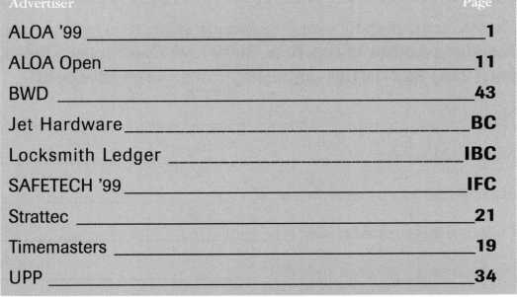

***Keynotes Advertisers Index***

March 1999

Keynotes

**Keynotes** readers get the last word...

Every year Keynotes awards the “Author of the Year” to the locksmithing scribe who has gone beyond the call of duty  
when writing and submitting articles to Keynotes. Since our readers are a vital part of the magazine’s success, we’ve  
decided to let this year’s award be decided by “Readers Choice!”

Review the list of articles below from April ’98 to March ’99 and select your favorite author. Feel free to comment  
on what influenced your author selection; and the stories you found to be the most valuable, and why.

Thank-you from Keynotes for your participation; and from our authors for your support and helpful feedback.

1998

APRIL

Low Tech Products

Sal Dulcamara, CML

Inside 3M

Steven Spiwak, CRL

A Conversation with Rovey

Paul Chandler

The Evolution of the Security Industry, Part III

Steven Spiwak, CRL

Servicing Mul-T-Lok Heavy Duty Padlocks

Sal Dulcamara, CML

Biometrics

Steven Spiwak, CRL

MAY

So You Can Do Safe Work Too?

James Jeffries

Impressioning Single Bitted GM Keys

Steven Spiwak, CRL

Promoting Your Business

Steven Spiwak, CRL

Reconstructive Surgeiy for Safes, Part I

Daniel Graffeo, CRL, CMS

The Ethics of “Do Not Duplicate”

Sal Dulcamara, CML

HPC’s In-A-Minute Auto Lock Decoder

Sal Dulcamara, CML

The Importance of Home Security

Steven Spiwak, CRL

JUNE/JULY Bi Lock

Steven Spiwak, CRL

A-I’s #J-50 Simplex 1000 Installation Jig

Sal Dulcamara, CML

InstaCode

Sal Dulcamara, CML

The Sliding Magnalock

Greg Perry, CML, CPS

Powerlever

Paul F. Chandler, CRL

Reconstructive Surgery for Safes, Part II

Daniel Graffeo, CRL, CML

AUGUST Key Master

Sal Dulcamara, CML

To Master Key or Not?

Jerome Andrews, CML

A Delicate Balance

Steven Spiwak, CRL

SEPTEMBER

Who Are the Crime Prevention Experts?

Sal Dulcamara, CML

Point/Counterpoint:Licensing

Sal Dulcamara, CML and Kathy Zaniolo, CPL

Unusual Locks, Unusual Methods

Sal Dulcamara, CML

The Role of the Professional Locksmith

Steven Spiwak, CRL

Behind the Scenes with ALOA Continuing Education

Paul Chandler, CRL

OCTOBER

Auto Lock Tools

Sal Dulcamara, CML

AutoTel Tells All

Sal Dulcamara, CML

High-Tech Ignitions

Fred Kosloske

The Chrysler 8-Cut Kit

Sal Dulcamara, CML

The Other Automotive Customer

Buddy Logan

GM Progression 101

Steven Spiwak, CRL

NOVEMBER

Is There a Drill Doctor in the House?

Sal Dulcamara, CML

A Simple, But Effective Tool (to Solve a Major Problem)

Steven Spiwak, CRL

Specialty Screwdrivers from Keedex

Sal Dulcamara, CML

The Singertech Neutralizer Tool

Sal Dulcamara, CML

New Life for an Old Install

Greg Perry, CML, CPS

Reading the Fine Print of Responsibility in Limited Warranties

Paul F. Chandler, CRL

Customer Feedback

Claire Cohen, CML

DECEMBER

Schlage Enters the 1-Core Market

A. J. Hoffman, CML

Image Vault Digital Security

James H. Glazier, CML

Is There a Niche for You In the Booming CCTV Market?

Paul F. Chandler, CML

Introducing e.Primus

Paul F. Chandler, CML

Best Type Interchangeable Cores, Part I

Charles H. Cole, CML

1999

JANUARY

Titan Commercial Series Lever Handle Lock

Sal Dulcamara, CML

Hardware Restoration

Don Dennis, CPL

Schlage AL-Series Lever

Sal Dulcamara, CML

Best Type Interchangeable Cores, Part II

Charles H. Cole, CML

Mississippi Learning

Paul F. Chandler, CRL

Abus Diskus-Now Rekeyable

Sal Dulcamara, CML

The PRP. Oh, How You’ve Changed!

Claire Cohen, CML

The Shop Van, Part I

Michael Ferrill

FEBRUARY

Access Control with a Little Help from Ma Bell

Paul Chandler, CRL

Motorcycle Locksmithing: Suzuki

Ray D’adamo, CML and Tina D’adamo, CRL

Puttin’ on the Blitz

Sal Dulcamara, CML

1C Tools from PRO-LOK

Sal Dulcamara, CML

The Shop Van, Part II

Michael Ferrill

MARCH

Business Growth Requires Modem Software Solutions

Paul Chandler, CRL

Car Keys and Computers

Sal Dulcamara, CML

Magazine Cross Reference from Data Logic

Sal Dulcamara, CML

So, You Think You Want To Be A Small Town Locksmith?

C. D. Lipscomb, CML, CPS

The Locksmith Business Card

Michael Ferrill

Computer Shortcuts

Claire Cohen, CML

Please submit your vote with the following information by mail, fax or email to:

**Keynotes** Author of the Year, 3003 Live Oak Street, Dallas, TX 75204 fax: (214) 827-1810 • email: [keynotes@anet-dfw.com](mailto:keynotes@anet-dfw.com)

Name:

Member Number:

My selection for Author of the Year is:

I selected this author because:

My favorite story/stories and why:



Keynotes

March 1999



Keynotes

Authors



Dept

M BL

m

Paul Chandler,

CRL, is the manager of the Electronic Security Department for IDN- ACME in Houston, TX. He was also "Keynotes Author of the YeaP’ for 1998.

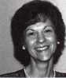

. Claire L. Cohen,

the second woman to become a CML,  
has been in locksmithing since 1977  
and has been writing articles for  
Keynotes since 1987.

I Sal Dulcamaro,

CML, has been in the locksmith  
business for over 23 years. He is the  
president of All Pro Security, Inc. in  
Michigan and has been an AIDA  
member for 16 years. A past president  
of the Locksmith Security Association  
of Michigan. Sal currently serves as  
editor of the association newsletter. He  
was named "Keynotes Author of the  
YeaP’ for 1996 and 1997.



Mike Emery is the

Editor t/Keynotes and a freelance  
music, film and real estate writer.



Mike Ferrill is a

third generation locksmith, who lives  
on the Island of Nantucket in Massa-  
chusetts.

Patanya Johnson is ALOA’s Communications Assistant

C.D. Lipscomb,

CML, CPS, lives in Corsicana,

Texas, and operates Navco Safe And Lock Co. He has been serving the public as a locksmith for 23 years. He is a member of ALDA, SAVTA, Greater Dallas Locksmith Association, Texas Locksmith Association, Metroplex Locksmith Association, The Oklahoma Master Locksmith Association and is a charter member of the Clearstar Online Locksmith Association. He has been awarded a Life Membership by the Greater Dallas Locksmith Association for outstanding service.

Tim McMullen

oversees legislative affairs for ALOA.  
He is a graduate of the District of  
Columbia School of Law and has  
an extensive background in  
legislative work.

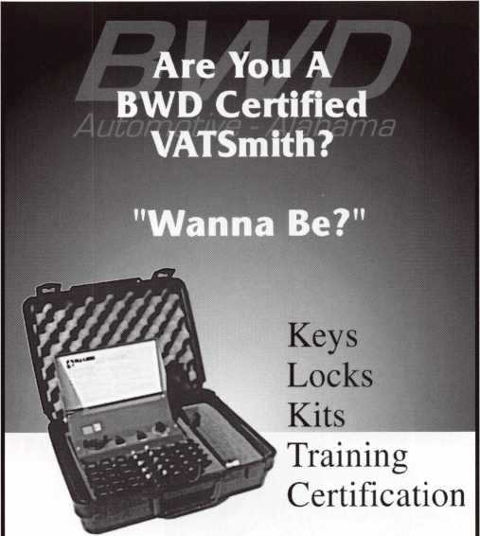

For a FREE VATSmith information packet and  
locations of BWD Certified VATS Centers  
Call



800**-**647-4926

See us at [www.alllock.com](http://www.alllock.com)

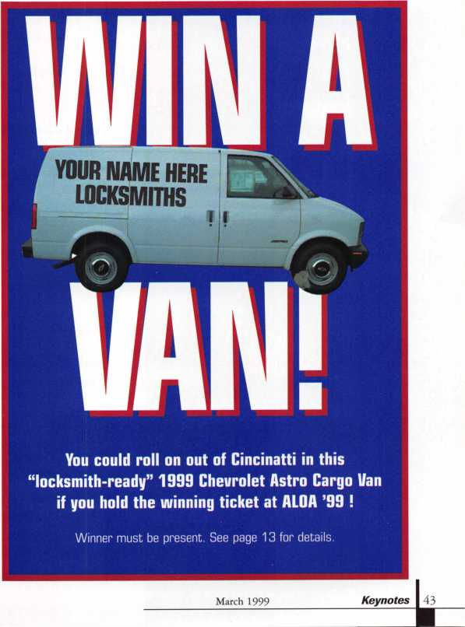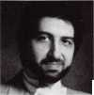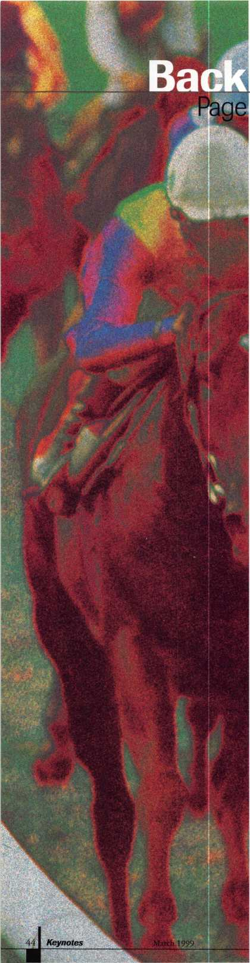

**Ahorse**

**is a horse,  
of course—**



Whether you love gambling, racing or just admiring the speed and strength of thorough­bred horses, Cincinnati’s River Downs Track is a must see for everyone. We’d like to send you to the track in style. No, not by a horse drawn carriage (although that would have been in line with the theme of this contest), but rather in a limousine! Hey, what more could you ask for?

What we’re asking for are correct answers to the following horse questions, so put on your thinking caps and send in your replies as quickly as possible.

Did we mention that you’ll also win a Way Cool ALOA ‘99 T-shirt? In fact, we’ll give all runners up a T-shirt too!

Name :

Daytime Telephone Number:

1 .Name the Lone Ranger’s AND Tonto’s horse’s names

and

1. Mr. Ed was a talking horse, but Francis was a talking what?
2. “Trigger” was the horse of a certain singing cowboy. Who was he?
3. Quick Draw MaGraw was a horse, but his sidekick wasn’t. What was he and what was his name?

Mail, fax or email your responses to:

HORSE QUIZ

**c/o** Keynotes

3003 Live Oak Street

Dallas, TX 75204

(214) 827-1810 fax

[keynotes@anet-dfw.com](mailto:keynotes@anet-dfw.com)

**nd my subscription to** Locksmith Ledger International

**JTW! Pleasef] start**

□ 3 YEARS (includes 36 issues, 3 FREE Annual Directory* issues)

USA $90.00

j 2 YEARS (includes 24 issues, 2 FREE Annual Directory* issues)

USA $64.00Canada $91.00International (air) $179.00International (surface) $119.00

| 1 YEAR (includes 12 issues, 1 FREE Annual Directory* issue)

USA $38.00Canada $52.00International (air) $95.00International (surface) $65.00

• Comprehensive guide to industry manufacturers, distributors, products and services.

**CARD INVALID UNLESS COMPLETE DATA IS GIVEN**You must indicate your locksmithing affiliation below

1. Are you a locksmith or an individual involved in locksmithing? □ YES □ NO
2. My position is: □Owner/Pres. 03 Employee 06 Student 09 Other
3. Business classification (check one only): A OLocksmith Shop B OHardware

C QWholesaler/Distributor DOManufacturer EOSecurity or Maintenance

10Consultant 3 Olndustrial 50Government  
20Commercial 40lnstitutional 60Police  
G QArchitect/Specifier Z OOther (specify)

1. Are you involved in purchasing or influencing the purchase of locksmith products?

□ YES QNO

**Send payment to: Locksmith Publishing Corp. * 850 Busse Highway • Park Ridge, IL 60068  
Phone: 847-692-5940 • Fax: 847-692-4604 • Website: [www.lpc.simon-net.com](http://www.lpc.simon-net.com)**

Name

Company

Address

CityStateZip PhoneFax

Payment: (US FUNDS ONLY) Money OrderCharge CardCheck #

Complete for Charge Orders Only: VISA Master Card

Account #Exp. Date

Signature

IM8

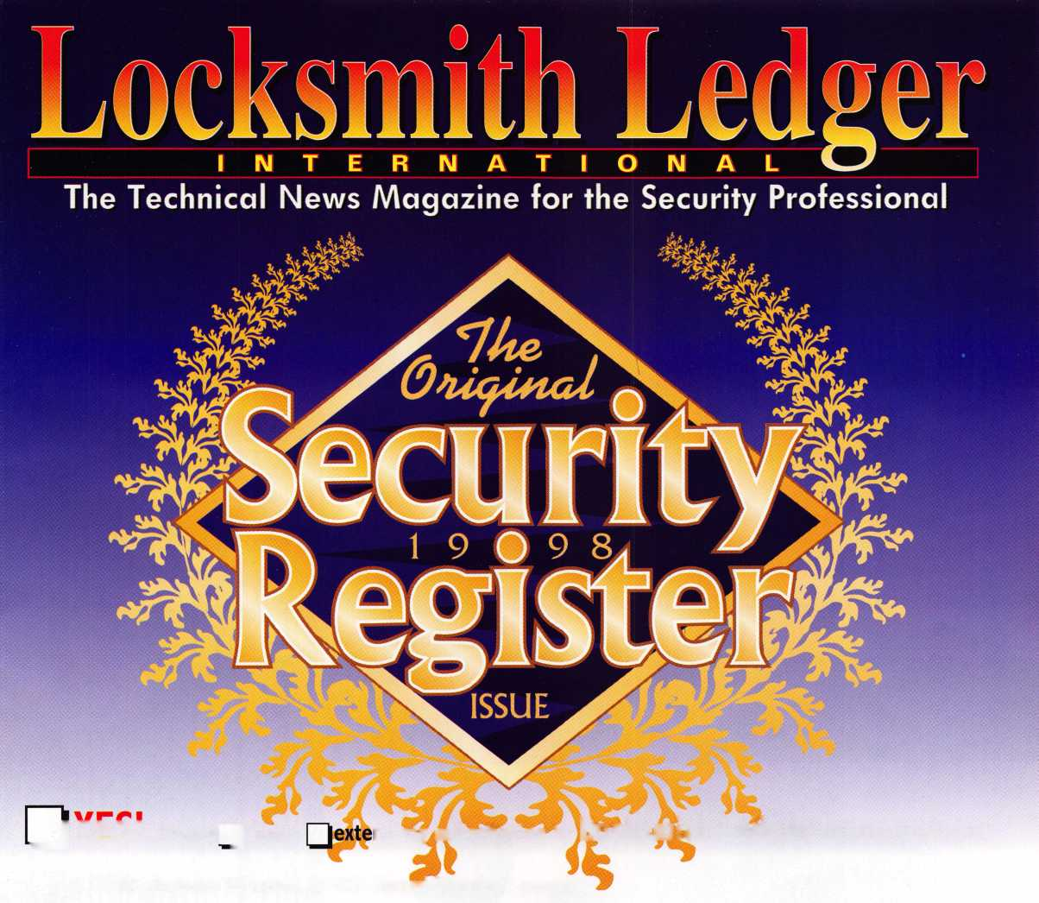

And you also  
don't have to  
be a car dealer  
in order to

duplicate  
transponder

keys.

All you have to be is a professional

locksmith and  
have a Jet ETD-1  
to duplicate  
transponder ^  
keys.

**Jets easy to use decoder quickly and accurately duplicates the most popular transponder keys, including CADILLAC CATERA, HONDA, ACURA, MAZDA and AUDI/VOLKSWAGEN.**

**Included with your purchase are 5 each of the above keys ( a value of $ 295.00)**

**JET HARDWARE MANUFACTURING CORP**

800 Hinsdale Street, Brooklyn, NY 11207

